Jennifer Odongo

FCEPH – Group 3

Contents

Table of Figures 5

**Project** 6

**Project Team** 6

**Introduction** 6

**Project Plan** 6

**Software Requirements** 7

**Charts and Diagrams** 0

**Risk Register** 0

**Group Meetings/Schedule** 0

**Technology used for meetings/collaboration** 0

**Project Lifecycle** 0

**Week 2** 0

**Week 3** 0

**Week 4** 1

**Week 5** 1

**Week 6** 1

**Week 7** 1

**Week 8** 1

**Week 9** 1

**Week 10** 1

**Week 11** 2

**Week 12** 2

**Week 13** 2

**Core Software** 2

**Website** 2

**Website Testing** 2

**Anis – Supplier Interface – Project Manager** 2

**Project Manager** 2

**Sub Project Plan** 2

**Risk Register** 2

**Requirements** 2

**Software** 3

**Component Integration** 3

**Testing** 3

**Jennifer – Loyalty Scheme – Documentation** 3

**Documentation** 3

**Sub Project Plan** 3

**Work Breakdown Structure** 3

**Gantt chart** 4

**Network Diagram** 4

**Risk Register** 4

**Requirements** 5

**Software** 5

**Login/register to clubcard** 5

**Point addition** 5

**Special deals** 5

**Component Integration** 5

**Testing** 5

**Nazir – Payment – Integration** 6

**Integration Planner** 6

**Sub Project Plan** 6

**Risk Register** 6

**Requirements** 6

**Software** 6

**Component Integration** 6

**Testing** 6

**Benjamin – Marketing - QA** 6

**Quality Assurance** 6

**Sub Project Plan** 6

**Risk Register** 6

**Requirements** 6

**Software** 6

**Component Integration** 6

**Testing** 7

**Appendix** 7

**Website** 7

**Style.css** 7

**Index.html** 7

**item.html** 7

**Groceries.html** 7

**freshfood.html** 7

**fruit.html** 7

**vegetable.html** 7

**salad.html** 7

**dips.html** 7

**smoothies.html** 7

**milk.html** 7

**yoghurts.html** 7

**cheese.html** 7

**dairyfree.html** 7

**meat.html** 7

**fish.html** 7

**cookedmeat.html** 8

**slicedcookedm.html** 8

**pies.html** 8

**readymeal.html** 8

**bakery.html** 8

**bread.html** 8

**wraps.html** 8

**pancake.html** 8

**muffins.html** 8

**croissant.html** 8

**scones.html** 8

**doughnuts.html** 8

**cake.html** 8

**frozenfood.html** 8

**frozenmeat.html** 8

**frozenfish.html** 8

**icecream.html** 8

**frozendesserts.html** 8

**frozenpizza.html** 8

**frozenchips.html** 9

**frozenpuddings.html** 9

**frozenpies.html** 9

**frozenreadymeal.html** 9

**foodcupboard.html** 9

**tins.html** 9

**biscuits.html** 9

**cracker.html** 9

**crisps.html** 9

**snacks.html** 9

**chocolate.html** 9

**sweets.html** 9

**gum.html** 9

**cereal.html** 9

**ingredients.html** 9

**mealkit.html** 9

**spaghetti.html** 9

**homebaking.html** 9

**jams.html** 9

**drinks.html** 10

**ghousehold.html** 10

**baby.html** 10

**pets.html** 10

**Clothing.html** 10

**Electronics.html** 10

**Pharmacy.html** 10

**Household.html** 10

# Table of Figures

**Figure 1 – Work Breakdown Structure 0**

**Figure 2 – Network Diagram 1**

**Figure 3 – Activity Diagram 0**

**Figure 4 – Critical Path Analysis 1**

**Figure 5 - Earned Value Analysis 2**

**Figure 6 – Risk Register 0**

**Figure 7 - Anis Risk Register 6**

**Figure 8 – Jennifer WBS 8**

**Figure 9 - Jennifer Gantt Chart 0**

**Figure 10 - Jennifer Risk Register 0**

# **Project**

## **Project Team**

FCEPH is a team with four members. Anis, Jennifer, Nazir and Benjamin.

Anis’s non-technical role in the team is project manager. As project manager, Anis was in charge of taking the group minutes. His technical role was to develop the suppliers interface component.

Jennifer’s non-technical role is documenting. This involved keeping track of the planning and development processes of this project. Her technical role was to develop the loyalty scheme component.

Nazir’s non-technical role is integration planner. This involved coming up with a way to integrate our individual components into the core software. His technical role was to develop the payment component.

Benjamin’s non-technical role is quality assurance. This involved checking over the work being produced and giving any suggestions on things that can be done to improve it. His technical role was to develop the marketing component.

## **Introduction**

The software we decided to develop was a website for a supermarket. The core is all the items for sale on view with a basket to store their items and check out. The payment component allows the user to pay for their items. The marketing component gives users sales. The supplier component lets a user buy more supplies and the loyalty scheme component lets a user get points for purchasing certain items.

## **Project Plan**

Our original plan had been to create two pieces of software for a supermarket. The two pieces of software would be an application and a website. The team would split so that Anis and Nazir would create the app and Jennifer and Benjamin would create the website. Anis and Nazir were chosen for the app as they had had experience with that. Jennifer and Benjamin were chosen for the website as they both had previous experience with that. This had not been a good idea because the project ended up being bigger than expected and there were not enough people for certain activities. Because of this many things had to be cut out of our software, requirements were changed and the app had to be ditched.

**Software and resources**

We used a number of software and resources in the planning and creation of our software.

To create the website, we decided to use Dreamweaver. We chose this program because of the split screen it provided. Dreamweaver allows you to view your code and your design at the same time. You get a live update for any code you add without having to open the website on a web browser to see what the code has done.

**Name**

The name of our group and supermarket is FCEPH. It stands for Food, Clothing, Electronics, Pharmacy and Household. This is because we wanted our supermarket to be one that sells all these things so we chose a name that would reflect this.

**Colour Scheme**

We chose the colours green, blue and white as our projects colour scheme. We used these colours throughout our project on charts and in our website. We chose these colours because we felt that they would be appropriate for a supermarket.

**Logo**



Jennifer designed this logo for the website.

### **Software Requirements**

We created a list of user requirements for each component of the software to help break down the tasks we needed to do. With this we were able to get the most important aspects of the software completed first leaving us with enough time to add any extra features we wanted. Because we had originally decided to create a website and an application, we wrote down three sets of core requirements. One was the overall requirement for the supermarket. The second was for the website and the third was for the application. We removed the application requirements when it we decided that we should stick to the website.

**Overall Requirement**

* A customer should be able to register/login or use software as a guest.
* A customer should be able to view a list of items on offer.
* A customer should be able to filter through the items on view.
* A customer should be able to select an item.
* A customer should be able to increase or decrease the quantity of items.
* A customer should be able to add items to a basket.
* A customer should be able to checkout.
* A customer should be able to set a delivery date

**Website Requirement**

Home Page

* Navigation bar (Groceries, Clothing, Electronics, Pharmacy and Home & Furniture)
* Slideshow
* Promo items
* Utility bar at the top (Login, settings, help, basket, account etc)
* Footer (Help, contact us etc)

Groceries Page

* Utility bar at the top (Login, settings, help, basket, account etc)
* Navigation bar (Groceries, Clothing, Electronics, Pharmacy and Home & Furniture)
* Sub navigation bar (Fresh food, frozen food, drinks etc)
* Footer (Help, contact us etc)
* View items
* Filter items
* Add item to basket
* Select items

Clothing Page

* Utility bar at the top (Login, settings, help, basket, account etc)
* Navigation bar (Groceries, Clothing, Electronics, Pharmacy and Home & Furniture)
* Sub navigation bar (Fresh food, frozen food, drinks etc)
* Footer (Help, contact us etc)
* View items
* Filter items
* Add item to basket
* Select items

Electronics Page

* Utility bar at the top (Login, settings, help, basket, account etc)
* Navigation bar (Groceries, Clothing, Electronics, Pharmacy and Home & Furniture)
* Sub navigation bar (Fresh food, frozen food, drinks etc)
* Footer (Help, contact us etc)
* View items
* Filter items
* Add item to basket
* Select items

Pharmacy Page

* Utility bar at the top (Login, settings, help, basket, account etc)
* Navigation bar (Groceries, Clothing, Electronics, Pharmacy and Home & Furniture)
* Sub navigation bar (Fresh food, frozen food, drinks etc)
* Footer (Help, contact us etc)
* View items
* Filter items
* Add item to basket
* Select items

Home & Furniture Page

* Utility bar at the top (Login, settings, help, basket, account etc)
* Navigation bar (Groceries, Clothing, Electronics, Pharmacy and Home & Furniture)
* Sub navigation bar (Fresh food, frozen food, drinks etc)
* Footer (Help, contact us etc)
* View items
* Filter items
* Add item to basket
* Select items

Item Page

* Utility bar at the top (Login, settings, help, basket, account etc)
* Navigation bar (Groceries, Clothing, Electronics, Pharmacy and Home & Furniture)
* Footer (Help, contact us etc)
* Item name
* Item image
* Item description
* Item price
* Change quantity
* Add item to basket

Basket Page

* Utility bar at the top (Login, settings, help, basket, account etc)
* Navigation bar (Groceries, Clothing, Electronics, Pharmacy and Home & Furniture)
* Footer (Help, contact us etc)
* View basket items
* Change quantity
* Remove item
* Checkout

Checkout Page

* Confirm order
* Cancel order

Login/Register Page

* Fields to enter Login/register details

Contact Us Page

* Utility bar at the top (Login, settings, help, basket, account etc)
* Navigation bar (Groceries, Clothing, Electronics, Pharmacy and Home & Furniture)
* Footer (Help, contact us etc)
* Contact us form
* Address
* Phone number

As time went by, we realised that we would have to remove some things from the requirement due to time running out. The last time we had to demonstrate we lost marks for having things that did not work so we saw it was better if those things were just removed so we would not have the same problems as last time. We removed the basket page and turned into a popup. We removed the login/register page because there was not enough time to get it to work.

### **Charts and Diagrams**

**Work Breakdown Structure**

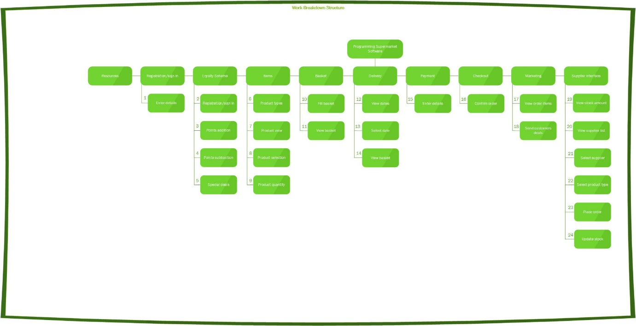

Figure 1 – Work Breakdown Structure

This diagram shows all the functions on our website that needs to be done. This is an image for the overall software, core and components. We used a work breakdown structure so that we could break down the project into manageable chunks. This made the project look much more manageable so we wouldn’t feel overwhelmed by the workload.

**Network Diagram**

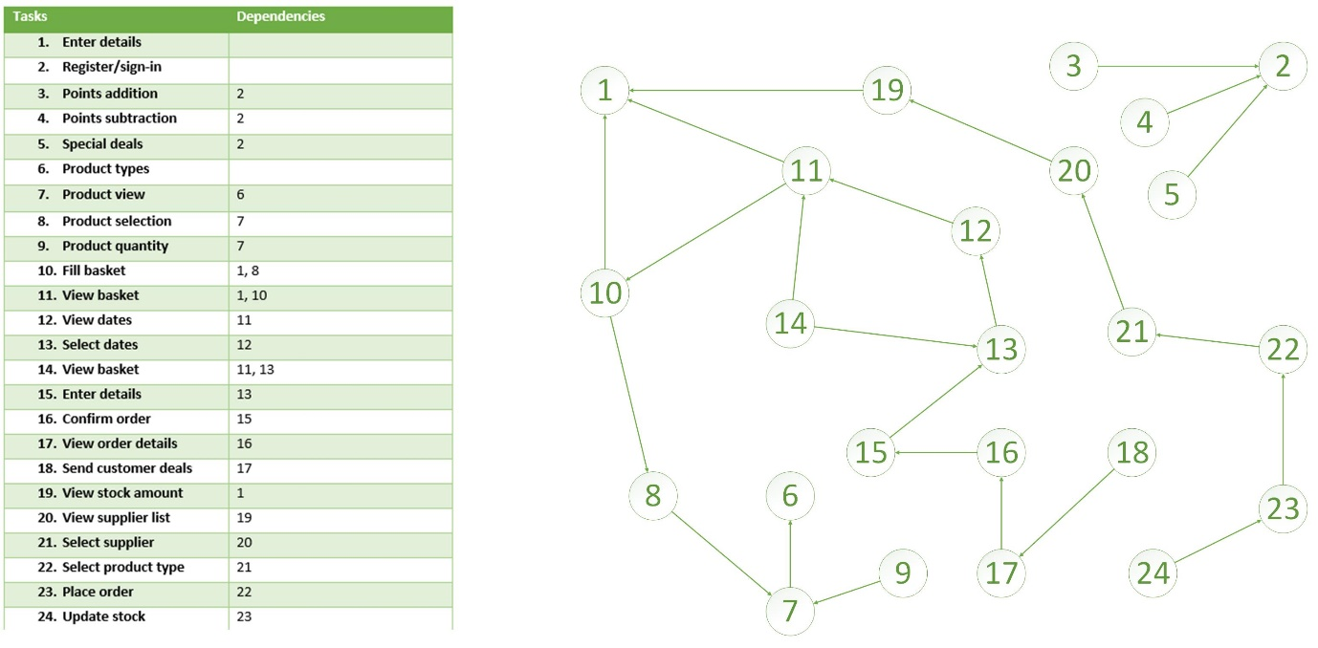

Figure 2 – Network Diagram

The network diagram is a more detailed version of the WBS, Work Breakdown Structure. It helps with identifying critical activities and the dependencies. The tasks with empty dependencies do not depend on any other tasks. 1 is for registration. 2 is for registration for a loyalty scheme. 3, 4 and 5 rely on 2 because a user has to be registered to get these benefits. 6 which is having different products does not depend on anything. 7 depends on 6 because there needs to be a product type for the re to be a view. 8 and 9 depend on 7 because a user needs to be able to view a product before they can select or choose quantity. 10 depends on 1 and 8 because user needs to be logged in to fill basket and they need to be able to select an item. 11 depends on 1 and 10 because user needs to be logged in and the basket needs to have some items. 12 depends on 11 because the basket needs to be filled before they can get to choose a delivery date. 13 depends on 12 because the user needs to be able to view the dates before they can select one. 14, the confirmation, depends on 11 and 13 because the basket needs to be filled and a date has to have been chosen.15 depends on 13 because a date has to have been chose. 16 depends on 15 because payment details have to be there. 17 depends on 16 because the order has to have been confirmed. 18 depends on 17 because the customer has to have placed an order before. 19 depends on 1 because the staff needs to be logged in to access the stock. 20 depends on 19 because there has to be low stock for the staff to want to update the stock. 21 depends on 20 because user needs to be able to view supplier before they can select. 22 depends on 21 because the user needs to select a supplier first. 23 depends on 22 because the user needs to select a product before they can place an order. 24 depends on 23 because an order needs to have been placed before the stock can be updated.

**Activity Diagram**

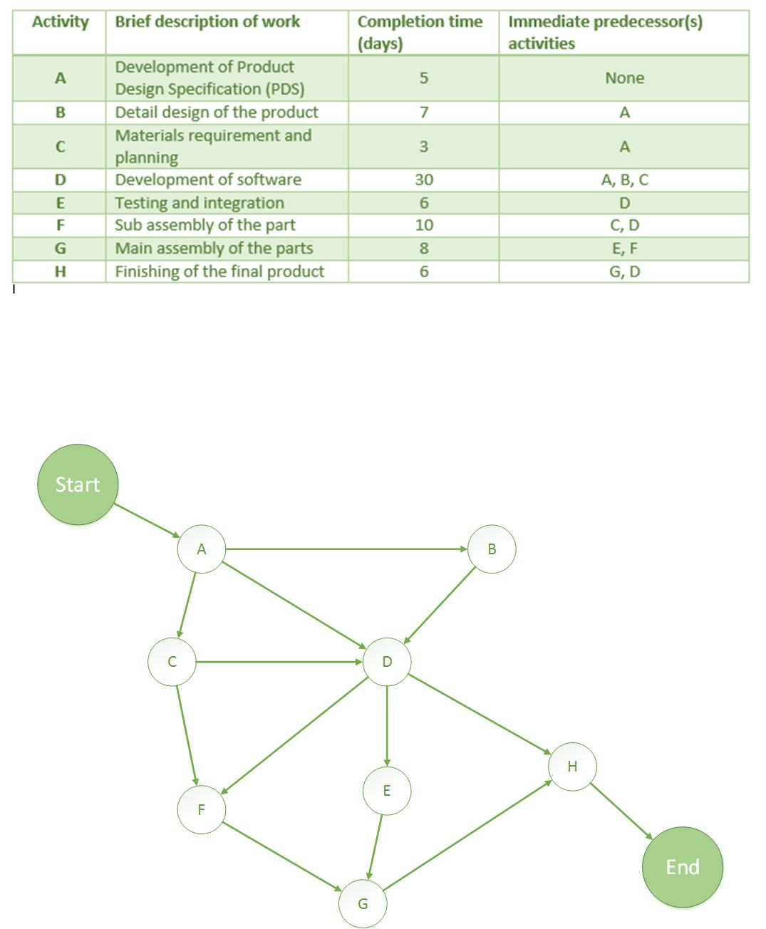

Figure 3 – Activity Diagram

Activity diagram shows the number of activities and its predecessors. This diagram shows that B is the predecessor of A as design specifications are needed for there to be a detail design for the software. C precedes A because it needs the design specification for the material planning to be done. D precedes A, B and C as it needs all of these before it can start. E precedes D because the software needs to have been developed for testing and integration to happen. F precedes D and C because the main component need to be completed and the material requirements and planning is needed to start it. G precedes E and F because the sup parts have to be finished and the program needs to be integrated for the main assembly. H precedes G and D because everything needs to have been completed.

**Critical Path Analysis**

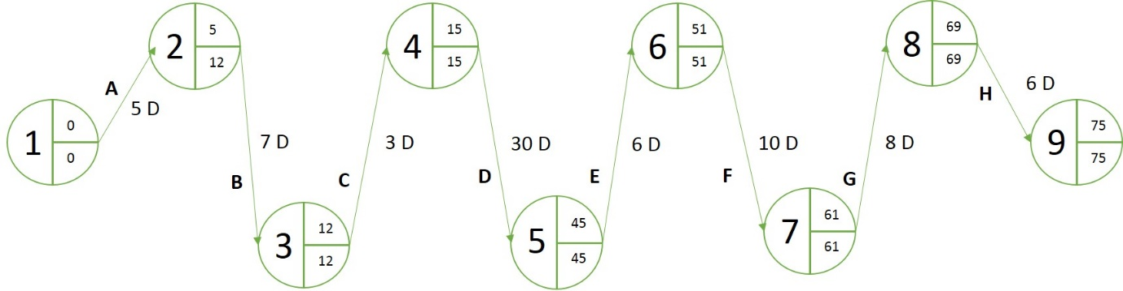

Figure 4 – Critical Path Analysis

The critical path analysis uses projects activities, duration time for those activities and dependencies to help with managing the project. This is done by estimating the earliest finishing time, EFT, and the latest finishing time, LFT.

The first activity, development of product design specification, would take an estimate of 5 days to complete. The second activity, detail design of the product, would take an estimate of 7 days to complete. This would be 12 days into the project. The third activity, materials requirement and planning, would take an estimate of 3 days to complete. This would be 15 days into the project. The fourth activity, development of software, would take an estimate of 30 days to complete. This would be 45 days into the project. The fifth activity, testing and integration, would take an estimate of 6 days to complete. This would be 51 days into the project. The sixth activity, sub assembly of the part, would take an estimate of 10 days to complete. This would be 61 days into the project. The seventh activity, main assembly of the parts, would take an estimate of 8 days to complete. This would be 69 days into the project. The last activity, finishing of the final product, would take an estimate of 6 days to complete. The 75 day would be the earliest finish time.

The LFT for the first activity is the 12th day. The LFT for the second activity is also the 12th day. The LFT for the third activity is the 15th day. The LFT for the fourth activity is the 45th day. The LFT for the fifth activity is the 51st day. The LFT for the sixth activity is the 61st day. The LFT for the seventh day is the 69th day and the LFT for that last activity is the 75th day.

Since the EST and the LFT are the same for most of the activities, those times would be the length of the activity. This also means that all the activities are critical.

**Earned Value Analysis**

Earned value analysis, EVA, is a system that allows you to see the relationship between the accomplishments that were planned and the accomplishments that were actually achieved. Planned value, PV, is the planned work. Earned value, EV, is the actual work and actual cost, AC, is the cost of completing that work.

Using the example given in the week 10 lecture, this software project is £30,000. This is for 6 weeks, as the core should be finished by then.

By fifth week core was only 30% complete so the actual cost is £50,000.

**Planned Value** = £25,000

**Earned Value** = £9,000

**Actual Cost** = £50,000

**Schedule Variance** = -£16,000

**Schedule Performance Index** = .36

**Cost Variance** = -£41,000

**Cost Performance Index** = .18

The total cost of the project will be £166,666.66

Figure 5 - Earned Value Analysis

The core was supposed to be completed by the 6th week but this did not happen. The main reason for this is because there had not been enough people assigned to the core development so progress fell behind drastically.

**Gantt Chart**

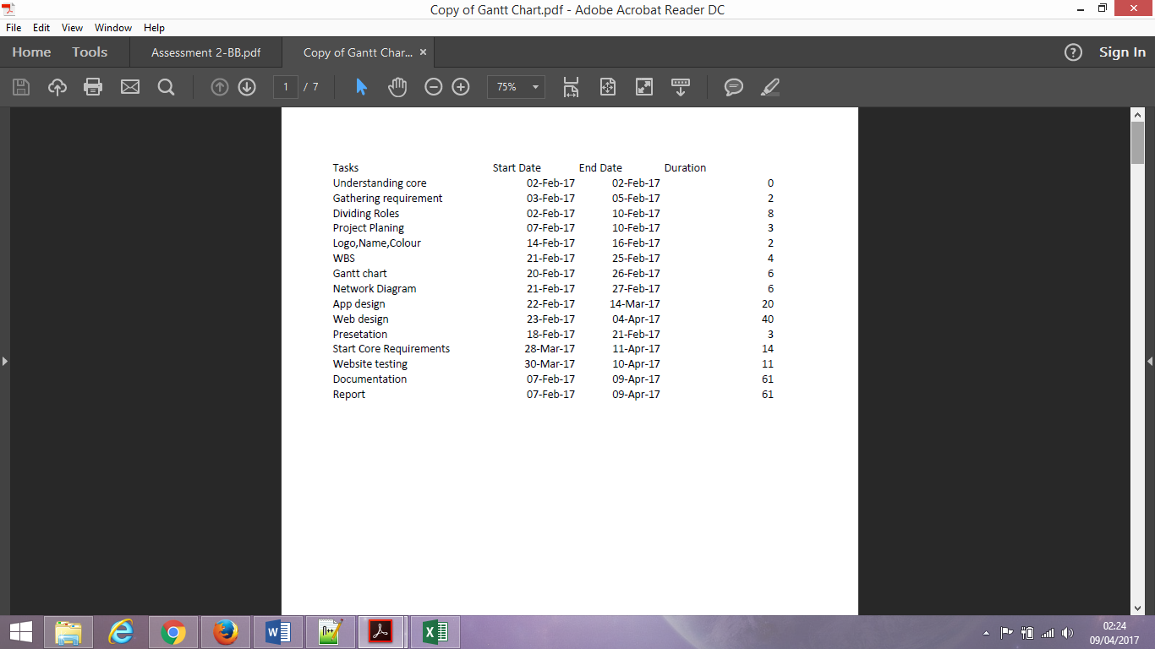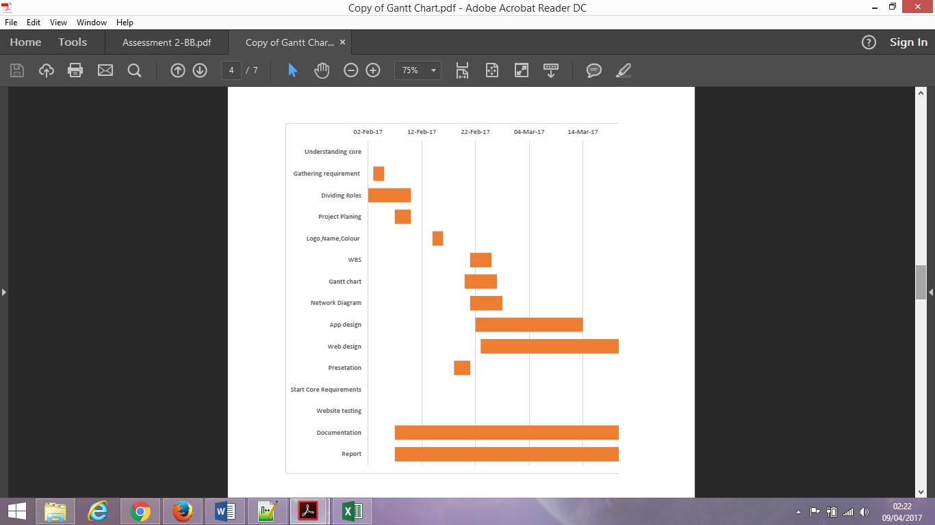

This Gantt chart shows the work we did over the course of our project.

### **Risk Register**

We created a risk register so that we could keep track of all the things we think can possibly go wrong or right in our project.

|  |  |  |  |  |  |  |  |  |  |
| --- | --- | --- | --- | --- | --- | --- | --- | --- | --- |
| No. | Rank | Risk | Description | Category | Root | Triggers | Potential Responses | Risk Owner | Status |
| R1 | 1 | incompletion | Not finishing the core on time | Negative | Not enough people working on an activity | Passing a deadline for an activity | Assign more people to task | Ben, Jen | Ongoing |
| R2 | 2 | communication | Not being able to inform others about certain tasks/issues | Negative | Some people have problems with phones/internet | An issue in the development | Have more group meetings | Ben | Ongoing |
| R3 | 3 | Resources | Not being able to get certain software’s to develop the core | Negative | Software not available/too expensive | Previous software not working out | Make sure necessary software is available to everyone | Everyone | Possible |
| R4 | 4 | Internet access | Not being able to access the internet therefore not being able to access resources | Negative | Not having internet | Being unable to do project because of internet | Spend more time in university doing work | Nazir | Possible |
| R5 | 5 | Free people | People being free to take up more tasks | Positive | Having free people | Somebody finishes their task early | Spend more time activities to try finish early | Ben, Jen | Possible |
| R6 | 6 | Inexperience | Not being able to do certain tasks | Negative | Not knowing html, CSS well enough | Needing more people to develop the website |  | Nazir, Ben, Anis | Possible |

Figure 6 – Risk Register

Risk 1 was the highest negative risk because our software was a website and some of our team members did not have enough web design skills. It was decided that two software’s were going to be developed. An application and a website. As time went on the team decided to stick with the website because time was running out and the website was more developed than the app. Anis and Nazir, the two developing the app, did not have the same amount of web developing experience as Jennifer and Benjamin. Assigning more people to the development of the core, which was now the website, would have been difficult.

Risk 2 is a negative risk because it was hard to get in contact with some members so lack of communication is a risk. Risk 3 is a negative risk because the software used to develop the website at university, Dreamweaver, isn’t a free software so some people may not be able to access that software. Risk 4 is a negative risk because some members mentioned that they did not have internet at home so doing the project at home would be an issue. Risk 5 is a positive risk because some people may complete their tasks in time so we could assign some people to another task. Risk 5 is a negative risk because we chose our core to be a software people did not have much experience with.

### **Group Meetings/Schedule**

Initially we created a schedule where we would meet twice a week. The first meeting would be during the practical sessions on Tuesdays and the second would be on a Thursday. We had also planned that at the end of each week we would check up on everyone’s work to see what they have done and if they have completed things on time.

It had been hard to get everyone to meet outside of normal university hours so we decided having one meeting a week would be fine and those meetings would be during the practical sessions on Tuesdays.

**Group meetings**

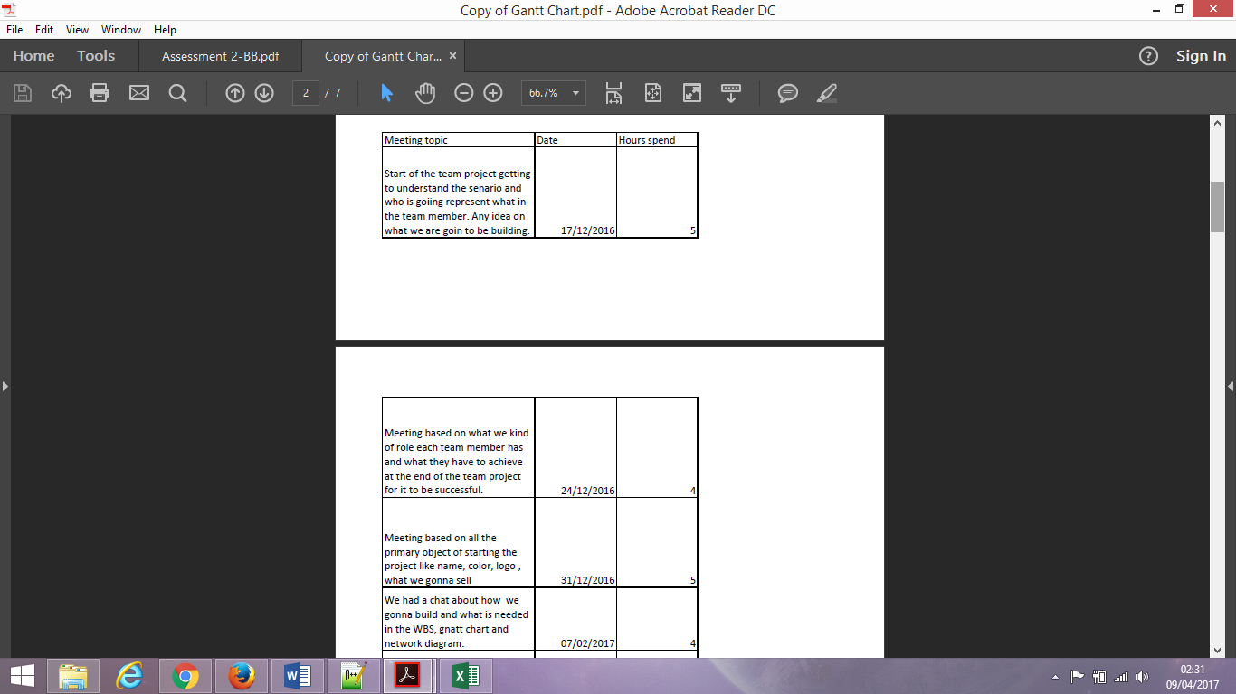



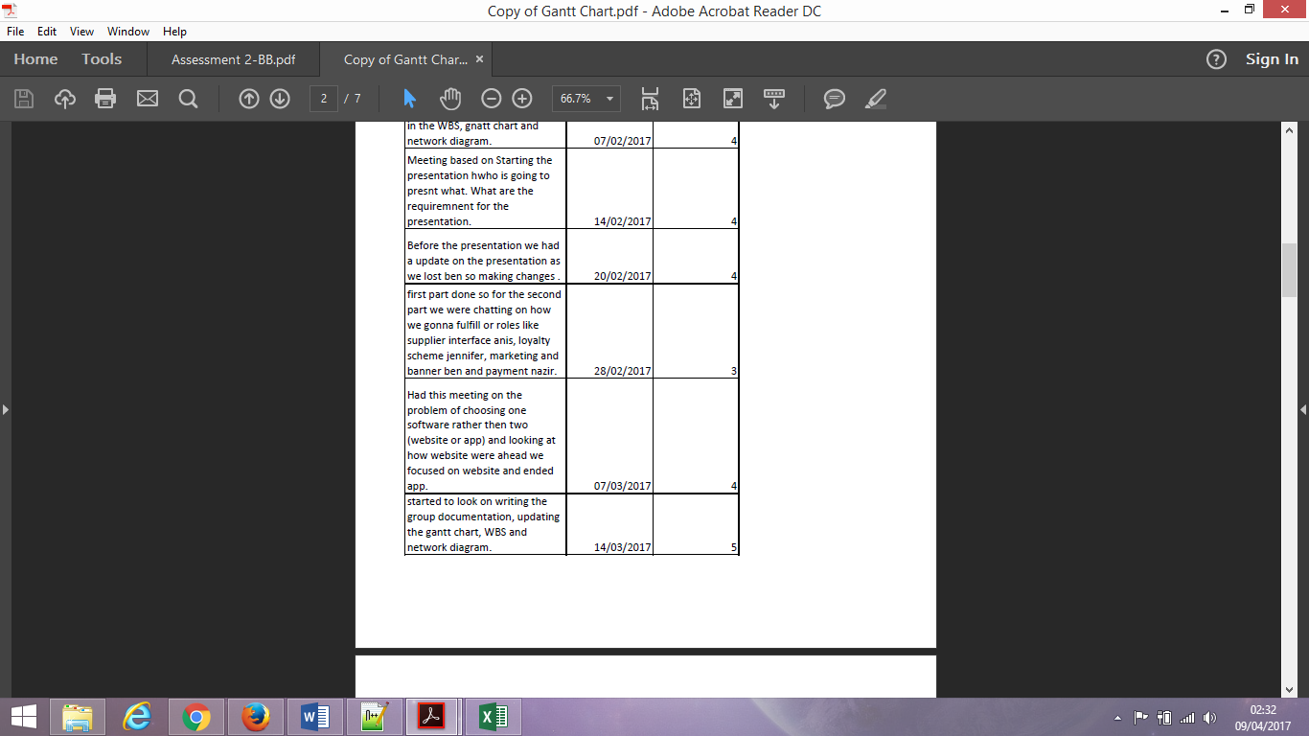

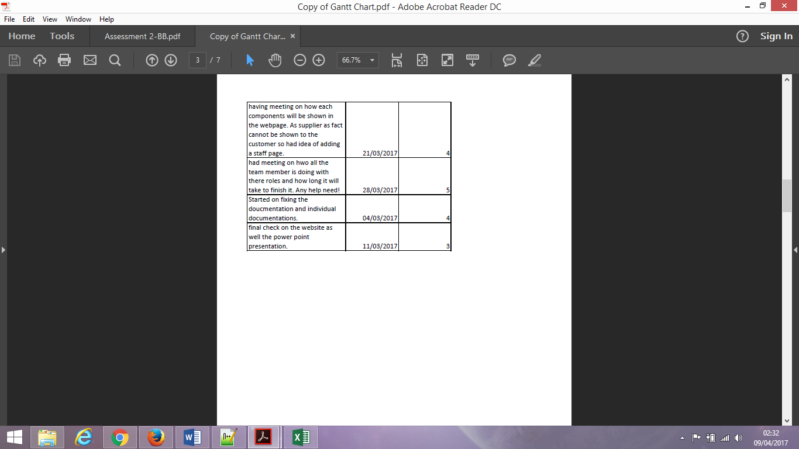

As time went by

### **Technology used for meetings/collaboration**

For collaboration we used Github. All the work that we produced was uploaded onto Github. This allowed us to collaborate as we did not need to be in the same room to see what another team member has done.

# **Project Lifecycle**

## **Week 1**

The first week of our project was spent on establishment. This involved recognising software requirements, defining roles, making a project plan and creating a schedule for the whole team to follow.

For the requirements, we read the case study, looked at the core and different components then used both of these resources to write down what we thought the software requirements would be. Things like customer being able to view items and placing items in baskets.

In defining roles, we looked at a list of roles, technical and non-technical, provided for us and discussed which roles we would be comfortable with. For the non-technical roles, it was decided that Anis would be the Project Manager because he know how to take minutes, something that was part of the role for a Project Manager. Jennifer took the role of Documenting as she felt she would be able to do this. Nazir was assigned the role of Integration and Benjamin was given the role of Quality Assurance. For the technical roles We decided that Anis would develop the Suppliers Interface component, Jennifer would develop the Loyalty Scheme component, Nazir would develop the Payment component and Benjamin would develop the Marketing component.

We also decided on a meeting schedule. We would have two meetings a week. One on a Tuesday and one on a Thursday.

## **Week 2**

The goal of the week was to name our supermarket, create a logo, choose a colour scheme and create templates for diagrams we were going to include. For example, Work Breakdown structure, Gantt Chart and other charts.

We were able to come up with a name for our supermarket. The name that we chose was FCEPH, a name created by Anis. We chose this name because it stands for Food, Clothing, Electronics, Pharmacy and Household. Nazir created the slogan “We don’t compromise on quality”. We also created the colour scheme for our project.

## **Week 3**

The goal of the week was to starts developing and create charts and diagrams for our project.

We created a work breakdown structure that would cover the whole project as well website and app separately. To create the WBS we used the requirements created in the previous weeks to identify all the tasks in our project.

We also set out who was going to develop what software. We planned that Jennifer and Ben would work on developing the website, which is our main core project as they have much more experience on the making website, while Nazir and I will start on the mobile app, which in the time seemed like a good plan. For the website, they used Notepad++ and for the mobile app, we have used Android studio.

We also started looking on making the Gantt chart for the following week until week 6 as that was our first deadline and predicting how much we can finish until then and beyond.

## **Week 4**

The goal of the week was to continue developing our core.

This was the week development officially started. Nazir started on creating the App while Jennifer started creating the structure and style for our web pages.

## **Week 5**

The goal of the week was to prepare for our presentation.

We had to look that there is not too much explanation on the slides or else they could find it a bit boring and less professional. Make sure the font and colour is presentable, reasonable sliding action. Had a chat on what each team member is going to present in the presentation and how they are going to present it (like the body language, eye contact, speed while speaking and many more).

As all of us had a bit of stage fright, we planned to practise a lot.

As far as the development was going me and Nazir were having a bit of graphing problem with the app so we decided show a prototype on how it will look but in the Jennifer and Ben website it was going fantastic which was ready to be presented. Which is what we went for as well.

## **Week 6**

This week’s goal was to deliver our presentation, finish the development of our core software and layout the plans for our individual development.

We prepared for our presentation by going over it in our spare time so that we all knew what to say but our preparations were a bit last minute so there was still some uncertainty amongst the group on how the presentation would go. Ben had been ill so had not been present for the presentation.

Because our core software was not finished, we did not start planning to begin our individual development.

## **Week 7**

The goal of the week was to try to finish the core software so that we could start our individual components.

This week we studied the network diagrams, which can be designed by recap of the WBS, estimations and Gantt charts. It is also called the activity diagram, which is more detailed WBS and supporting explanations.

The development process for the core was still ongoing so nobody started their individual component at this point.

## **Week 8**

The goal of the week, like last week, was to try to finish the core software so that we could start our individual components.

This week like the last was spent on the development of the core, which was still not completed.

## **Week 9**

The goal of the week was to finish the core software so that we could start our individual components and start documentation.

We had a meeting regarding the issue that we had two pieces of software, the app and the website, that were nowhere near completion. So we discussed on leaving one or the another, looking at how the website was going ahead of the app we decide on focusing all the team member on the website and starting to focus in the core so that we could get it out of the way and start our individual components. We were aware that this could be a problem because two of our members did not have web development skills so them having to create there components on a website would be an issue.

We also started the group documentation.

## **Week 10**

The goal of the week was to finish the core software so that we could start our individual components and continue documentation.

The week was spent solely on developing the core.

## **Week 11**

The goal of the week was to finish the core software so that we could start our individual components and continue documentation.

This week was spent on writing the documentation, creating any charts or diagrams we were missing, developing the core and creating our individual components. Because some of our team members were not experienced when it came to web development, we could not assign more people to the task so it took a long time for the core to reach a somewhat complete state.

## **Week 12**

The goal of the week was to finish the core software, finish our documentation, finish our components and create our presentation.

We were able to finish our components and documentation on time so we were able to focus on the presentation that was coming up. We decided the presentation would recap what our software was about then introduce everybody with his or her component.

# **Core Software**

## **Website**

### **Items View**

Items view is the list of all the items in the website as a grid.

Code

<li class="gridItem">

<a href="item.html" style="text-decoration:none" style="color:#000"><img id="iimg" src="images/media_888500_L.jpg" width="175" height="150" alt="item"/>

<div id="productContent">

<p id="name" style="color:#000">Loose Banana</p>

<p id="desc" style="color:#000">£0.75</p></a>

<button type="submit" style="margin-left:50px;" onclick="AddtoCart('Loose Banana', '100g', 1, 0.75)">Add</button>

</div>

</li>

This is the html for an item. Each item on a page uses this form to display the items for that category. An image of the item goes into the img tag. Under that is a div with two p tags. The first one holds the name of the item whilst the second hold the description. The img and p tags are surrounded in an a tag. This tag adds a link to these three tags. If someone clicks on the image, name or description it should take them to another web page. In this case it takes the user to the item page where you see a more detailed description of the item. Under these tags is the button tag. this is a button that uses an onclick method to add the item to the basket.

### **Item Page**

The item page contains a more detailed version of the items.

<div id="item" style="float:left">

<h2 style="float: left">Red Seedless Grapes 500g</h2><br>

<img src="images/media_889001_L.jpg" width="270" height="170" alt="Apple"/>

<div>

<p>£1.75</p>

<input type="text" value="1" name="quantity"/>

</div>

</div>

<div id="itemDesc" style="float:right" width="400">

<p>Country of Origin

Grown in Brazil, Chile, Egypt, Greece, India, Israel, Italy, Lebanon,

Morocco, Namibia, Peru, Portugal, South Africa, Spain, USA, Zambia

<br><br>

Size

500gg</p>

</div><div style="width:100;"><button type="submit">Add</button></div>

The item page has the name of the item, the image for the item, an input field for the quantity, an add button and a more detailed item description.

### **Basket**

The basket is made using JavaScript. It has a function that adds items to a hidden table in a webpage. When a user clicks on the basket button it opens a popup which displays the contents of the basket

<script src="basket.js"></script>

<li class="utility_option"><a onclick="document.getElementById('id01').style.display = 'block'" class="utility_option_link"><img src="images/basket.png" width="20" height="21" alt="Basket" /><span>Your Basket</span></a></li>

I first imported the basket JavaScript then added an onclick function to make the basket visible if a user clicks on the your basket section.

### **Login**

Like the basket, the login section is a popup that appears when a user clicks on the Signin/register section.

<div class="container">

<label><b>Email</b></label>

<input type="email" placeholder="Enter Email" name="uname" required>

<label><b>Password</b></label>

<input type="password" placeholder="Enter Password" name="psw" required>

<button type="submit">Login</button>

<input type="checkbox" checked="checked"> Remember me

<span class="reg"><a href="signup.html">New Customer?</a></span>

</div>

The login popup has two input fields, email and password. When a user clicks on the button after entering their details it will take them to the account page.

### **Delivery**

For the delivery page, I created a table that would list all the dates of the month. Using CSS and JavaScript to allow a user to select a date.

var list = document.querySelector('tbody');

list.addEventListener('click', function(ev) {

if (ev.target.tagName === 'TD') {

ev.target.classList.toggle('checked');

}

}, false);

When a user selects a table item it gives that, item the checked class. The checked class has a CSS style that changes the background colour of that item to show that it has been selected.

### **Checkout**

The checkout page is a message telling the user that their order is complete.

<style>

**#confirm**{

**border**: **1px** **solid** **#DFDFDF**;

**border**-radius: **5px**;

**padding**: **20px**;

**width**: **400px**;

**margin**: **auto**;

}

</style>

<div id="confirm" style="background:#fff;">

<div><b>Order No:33659194</b></div>

<div><p>Your order has been confirmed. Thank you for shopping at FCEPH</p></div>

</div>

<div id="checkout" style="float:right;" width=100>

<a href="index.html"><button>Continue Shopping</button></a>

</div>

A div contains the message for the user giving them their order number and telling them their order has been confirmed. In addition, a button takes the user back to the index for them to continue shopping.

## **Website Testing**

### **Items View**

All the items are listed in the same view.

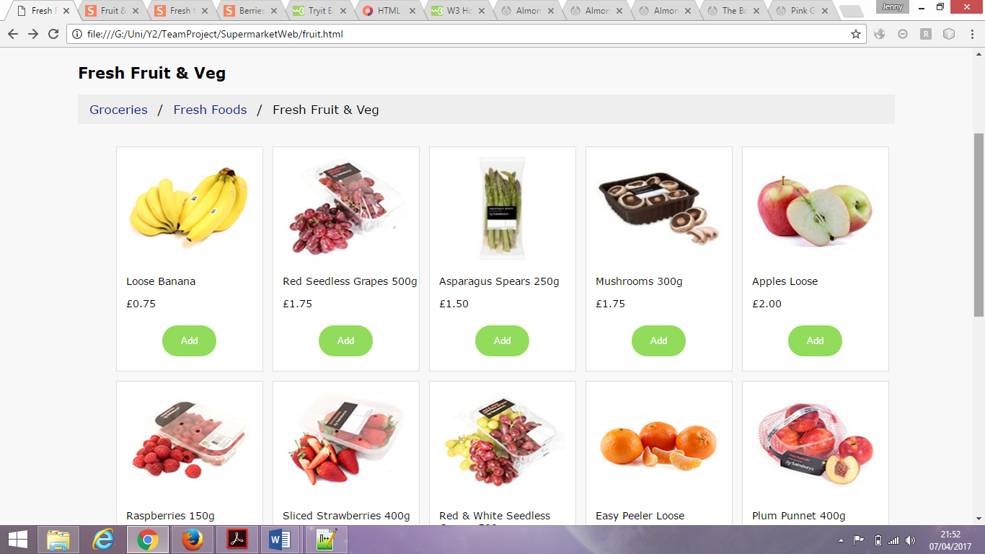

When clicked on the item takes you to an item page.

### **Item Page**

The item page has the item name, image, price, description, quantity and add button as expected.

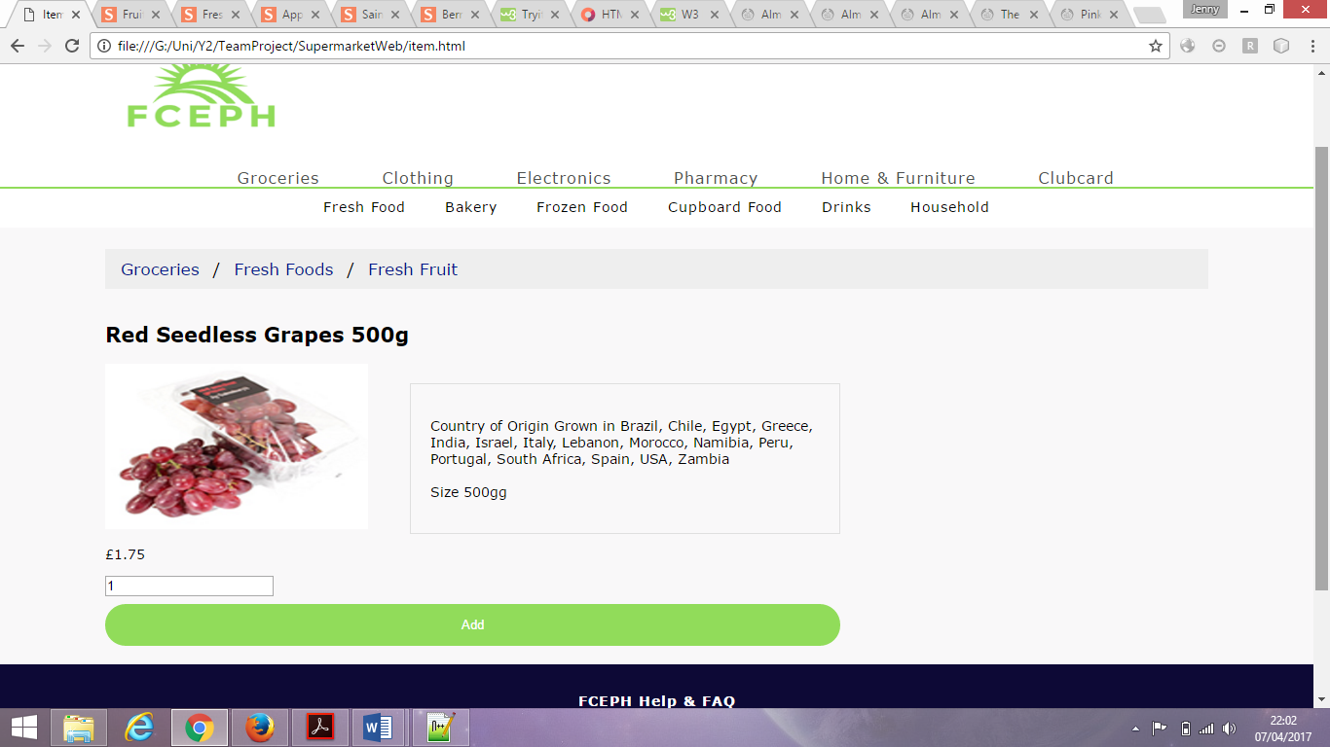

### **Basket**

When ‘Your Basket’ is selected, the basket appears as a popup.

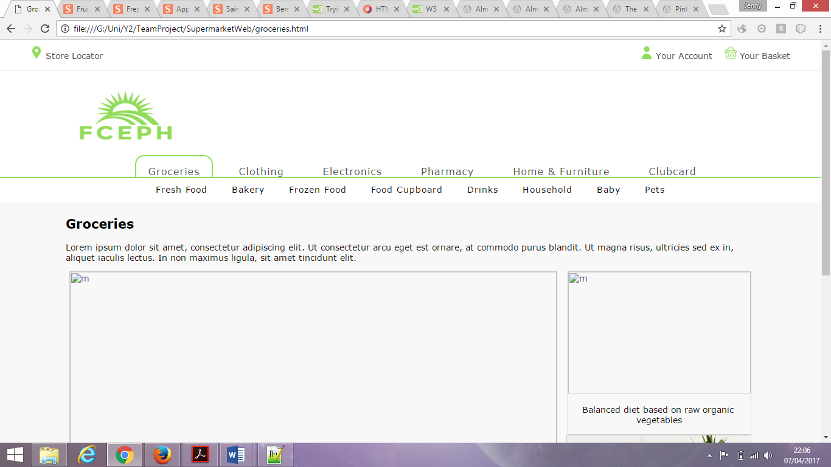

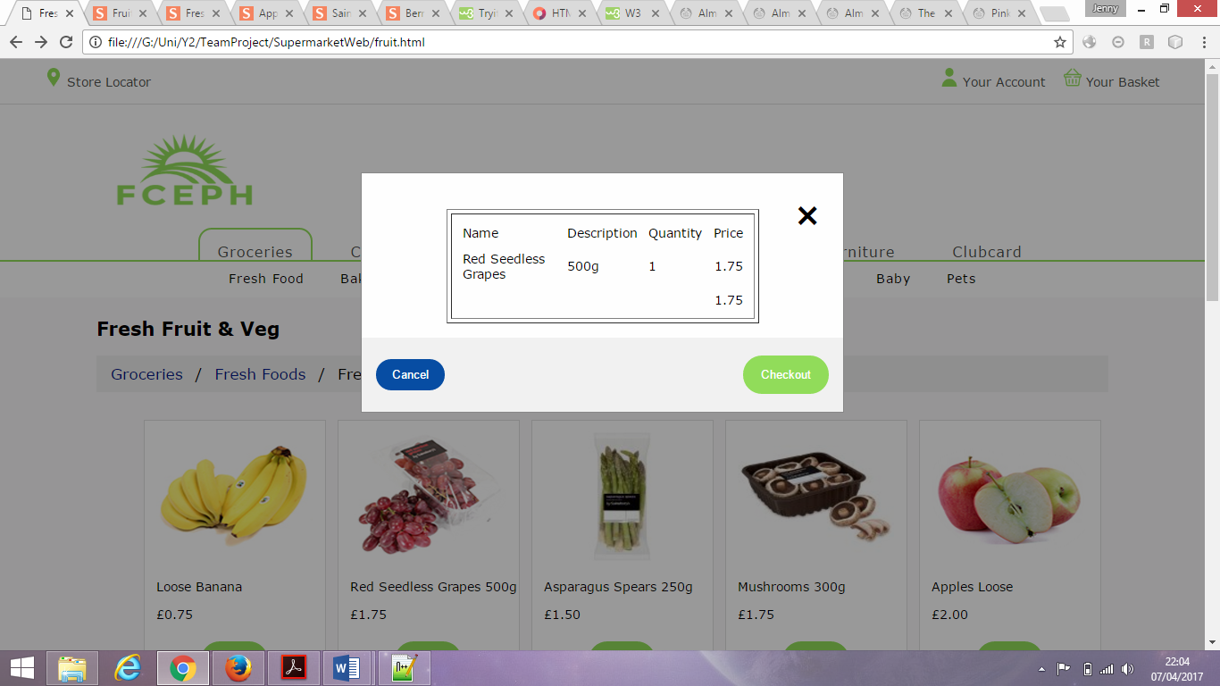

### **Login**

When ‘Sign in/Register’ is selected, the sign in popup appears.

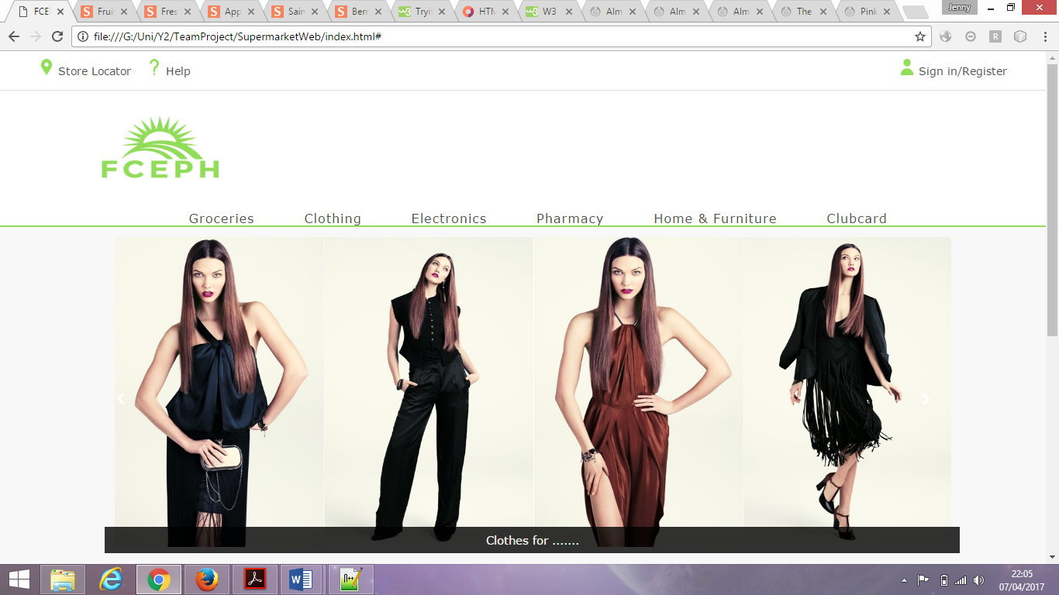

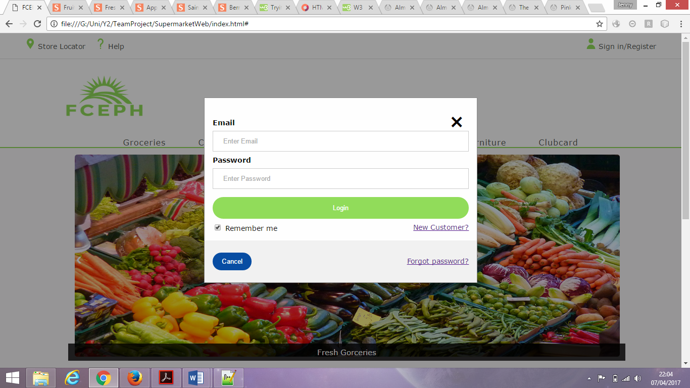

### **Delivery**

When an item on the table is selected, the items background colour changes to show it has been selected.

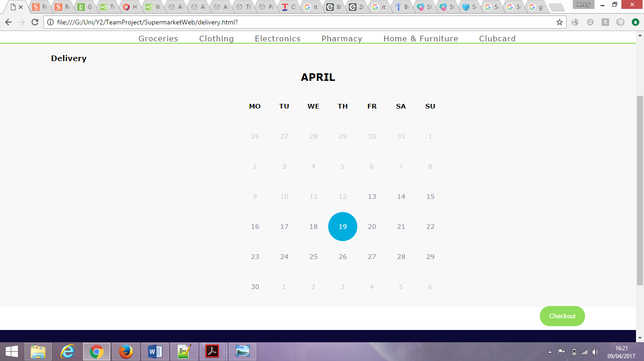

### **Checkout**

A page with a confirmation message appears.

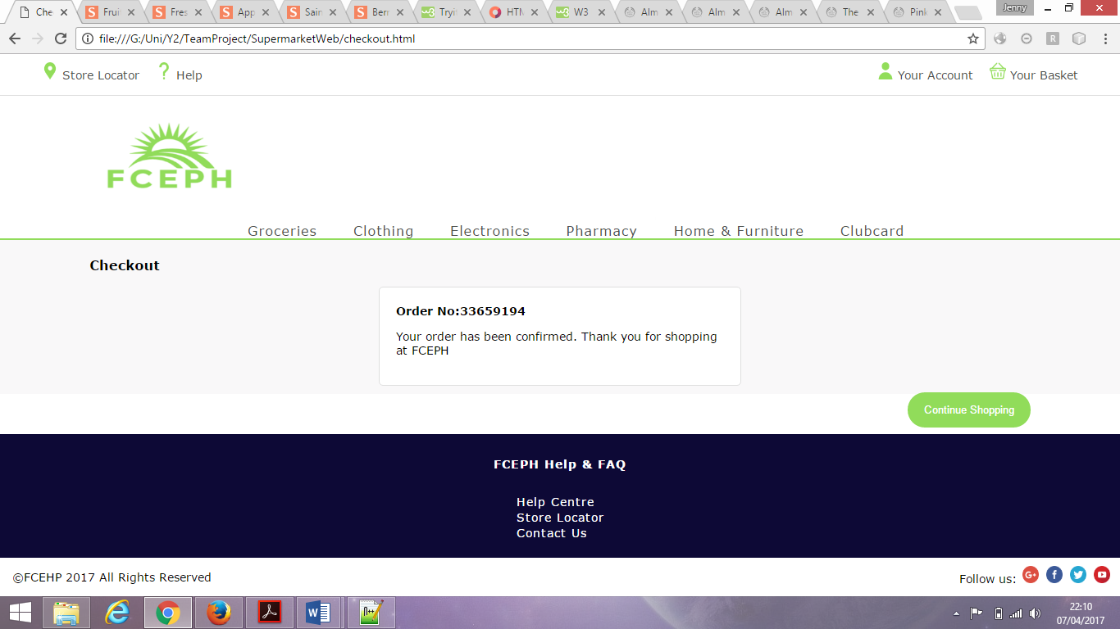

# **Anis – Supplier Interface – PM**

## **Project Manager**

As a project manager, I have a job like meeting time documentation making sure to take time of all the meeting we have in the class and out in the library, also to make sure to note all the main details on that meeting.

Also making the project plan such as for first part of the assignment we were full of ideas on what we wanted to make and looking on that we decided on making the F.E.C.P.H supermarket the letter in the name represent all the product that we will be selling such as F (food), E (electronic), C (Cloths), P (pharmacy), H (house and furniture). Also decide to make both app and website which at time looked good but as week passed we realised more error and lack in time got us to make a decision to choose on component to work on so looking at how underdeveloped and error app was having we decide to come back on to finish it If time we spared. So that was my another job as a project manager to take everyone options and move on it.

## **Sub Project Plan**

As for me, my sub project plan will be working on the supplier list, which is to provide a proper and reliable supplier with their name and link on the website, which the user will be able to look upon.

Another was the mobile app, which was on hold for the lack of time as well the error we were having on it.

## 

## **Risk Register**

This are some of the risk that I have found with in throught the team project some with me and some with the whole team:



Figure 7 - Anis Risk Register

## **Requirements**

This are the requirement that we came up with for the suppliers interface but as week pass there are some of the requirement, which has to be removed because of the time delayed.

**Supplier Interface Requirements**

* User should be able to view stock amount. **REMOVED**
* There should be a list of suppliers with their details.
* User should be able to select a supplier.
* User should be able to select type of product from supplier.
* User should be able to place order with supplier.
* Stock should be updated. **REMOVED**

## **Software**

I have been using the Notepad++ for the making of the website. While making a html page. As for the app, we were using android studio.

## /Users/anis/Desktop/Screen Shot 2017-04-07 at 21.03.34.png**Component Integration**

This is my role the supplier interface that is to create a supplier page so that the user can see the list of all the suppliers.

## **Testing**

After it all listed and done I am to check each button if they will open to the each supplier webpage. In which there will be products that can choose to order from.

# **Jennifer – Loyalty Scheme – Documentation**

## **Documentation**

My role in the project was documentation. I documented everything that went on in the project. I kept track of all the charts and diagrams created for the project. I documented the progress of the project and I created the group report.

## **Sub Project Plan**

My sub project was to develop a loyalty scheme system. This component would be for customers who have an account with FCEPH.

### **Work Breakdown Structure**

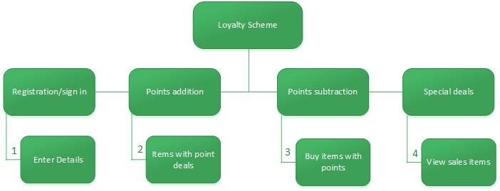

Figure 8 – Jennifer WBS

This is the work breakdown structure for my component. A user should be able to log into their clubcard account. A user should be able to view items that give extra points. A user should be able to buy items using their points and a user should be able to view special deals.

### 

### **Gantt chart**

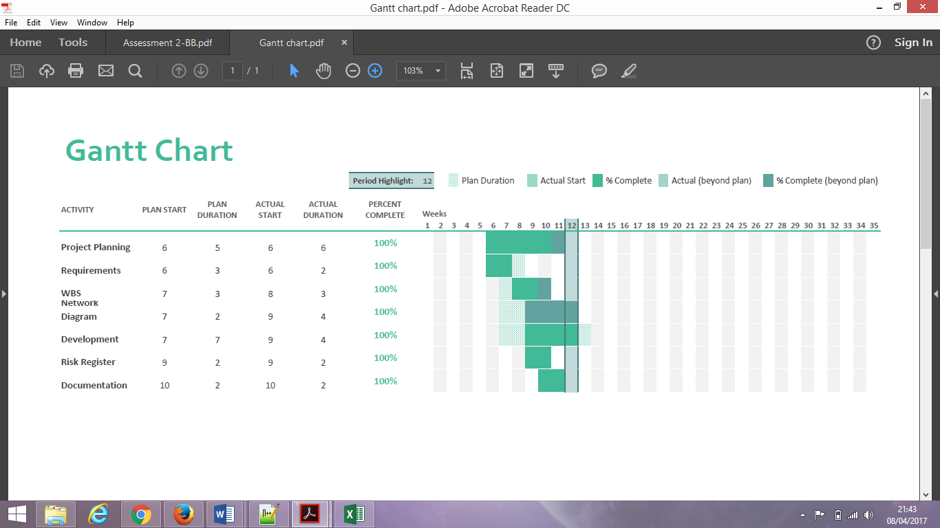

Figure 9 - Jennifer Gantt Chart

The first few weeks were spent on project planning. This includes things like setting out the requirements and creating charts and diagrams. In the 9th week I started creating the risk register and also started developing my component. This went on for 4 weeks. In the remaining weeks I tested my component, integrated it into the main software and documenting all that I had done.

### 

### **Network Diagram**

|  |  |
| --- | --- |
| Tasks | Dependencies |
| 1. Enter details | none |
| 1. View items with points | none |
| 1. Buy items with points | none |
| 1. View items on sale | 1 |

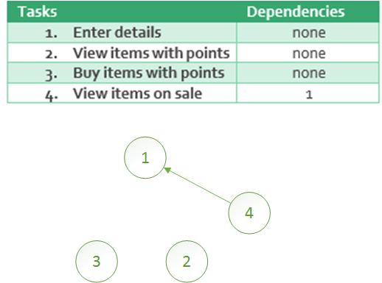

Tasks 1,2 and 3 do not have any dependencies while takes 4 depends on task 1. This is because the items on sale are only for those who have an account with the clucbcard.

## 

## **Risk Register**

|  |  |  |  |  |  |  |  |  |  |
| --- | --- | --- | --- | --- | --- | --- | --- | --- | --- |
| No. | Rank | Risk | Description | Category | Root | Triggers | Potential Responses | Risk Owner | Status |
| R1 | 1 | Incompletion | Not finishing the sub component on time | Negative | Started component late because core was unfinished | Passing deadlines set for tasks | Spend more time on component | Jennifer, Ben | Risk avoided |
| R2 | 2 | Extra time | Finishing things on time/early | Positive | Spending more time on the component | Finishing the component early | Spend more time on component | Jennifer | Risk avoided |
| R3 | 3 | Document | Not finishing the documentation on time | Negative | Being behind with the development | Passing set deadlines | Spend more time on component | Jennifer | Risk avoided |

Figure 10 - Jennifer Risk Register

The first risk is the most

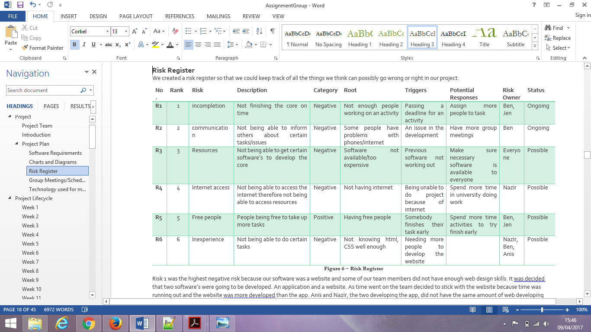

## 

## **Requirements**

At the beginning of my sub project the requirements had been:

**Loyalty Scheme Requirements**

* A customer should be able to register to a loyalty company.
* A customer should be assigned a loyalty card. **- removed**
* Points should be added to a loyalty card when the customer shops.
* Points should be removed from a loyalty card when customers use their loyalty card as payment. **- removed**
* A customer should receive special deals for loyalty points and discounts.

As time went by, I realised that I could not fulfil all the requirements on time so I had to remove the assignment of a loyalty card and just implied to the user that there was some kind of card. I did not have enough time to program the removal of points so that was removed. I only implied that points would be added if certain products were purchased.

## **Software**

### **Login/register to clubcard**

There is a button on the clubcard page. This button is for users who do not have club cards. If they do not have a club card, it means they are not a member and so need to sign up and create a clubcard account. They will be taken to the sign up page where they will have to enter their details and create an account.

<a href="signup.html"><button> Don't have a club card?</button></a>

<label><b>Title</b></label><br>

<select name="title">

<option value="1"> Please Select</option>

<option value="2"> Miss</option>

<option value="3"> Mr</option>

<option value="4"> Mrs</option>

<option value="5"> Ms</option>

</select><br>

<label><b>First Name</b></label><br>

<input type="text" name="fname" required><br>

<label><b>Last Name</b></label><br>

<input type="text" name="sname" required><br>

<label><b>Email Address</b></label><br>

<input type="email" name="email" required><br>

<label><b>Password</b></label><br>

<input type="password" name="psw" required><br>

<label><b>Confirm Password</b></label><br>

<input type="password" name="psw" required><br>

<label><b>Postcode</b></label><br>

<input type="text" name="pst" required><br>

The button is linked to the sign up page. The sign up page has input fields and labels. The labels give a title to the individual input fields so that users will know what information to put into what field.

### **Point addition**

Using the same format as the items page, I listed a few special items that would give users extra points. This section is only visible when a user has signed up.

<li class="gridItem" style="height: 250px;">

<img id="iimg" src="images/media_888500_L.jpg" width="175" height="150" alt="item"/>

<div id="productContent">

<p id="name" style="color:#000">Loose Banana</p>

<p id="desc" style="color:#91DC5A">5 points</p>

</div>

</li>

The item section has the name of the item and the point a user can get if they buy that item.

### **Special deals**

Special deals are images that show the users the kind of things they can get from having a clubcard.

<div class="responsive" >

<div class="img">

<a target="_blank" href="#">

<img src="images/zoo.jpg" alt="m" width="270" height="200"></a>

<div class="desc">Buy tickets to the London Zoo</div>

</div>

</div>

## **Component Integration**

I added a Clubcard link to the website so that a user would always see it and could go there straight away.

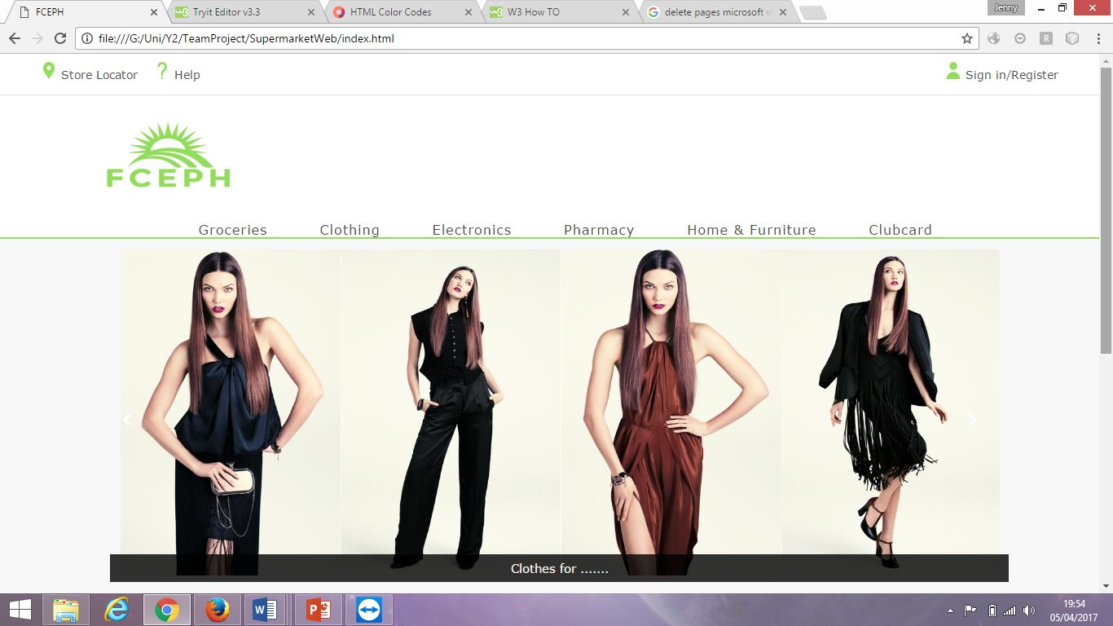

## **Testing**

### **Login/register to clubcard**

When a user clicks on the ‘don’t have a club card?’ button, it takes them to the sign up page. The sign up page has input fields for a user to sign up. When they sign up it takes them back to the clubcard page.

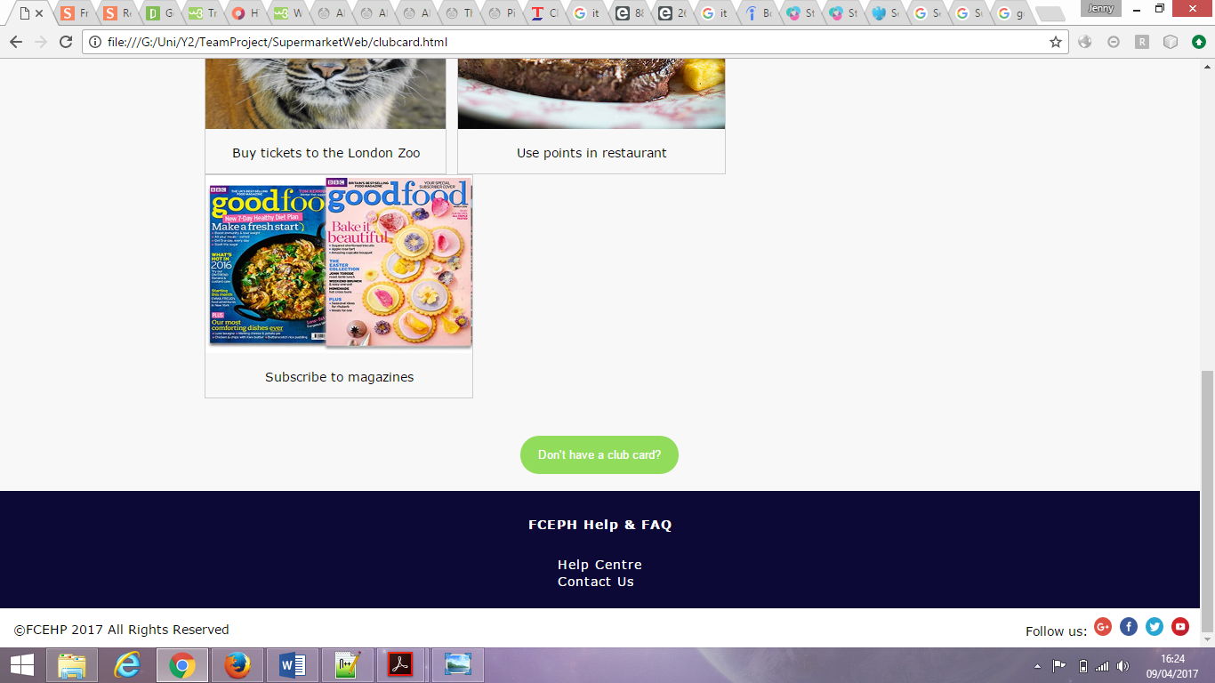

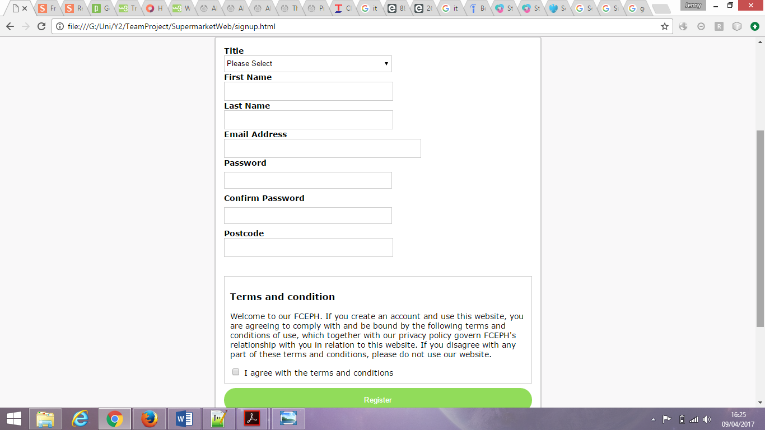

### **Point addition**

For this, I listed a few items with points to show users the types of products they can buy to earn points.

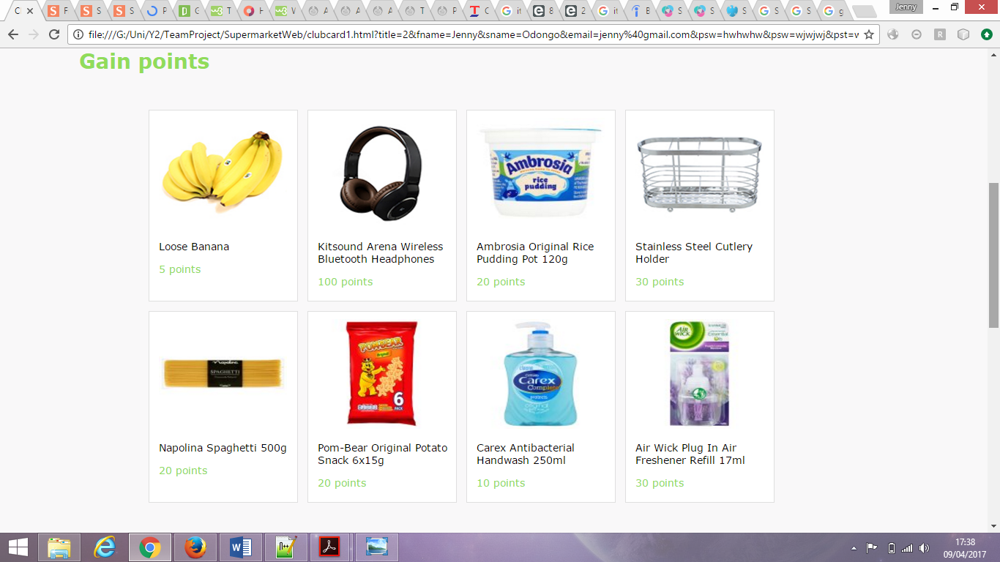

### **Special deals**

These images show the benefits that come with owning a clubcard and where the points can be used.

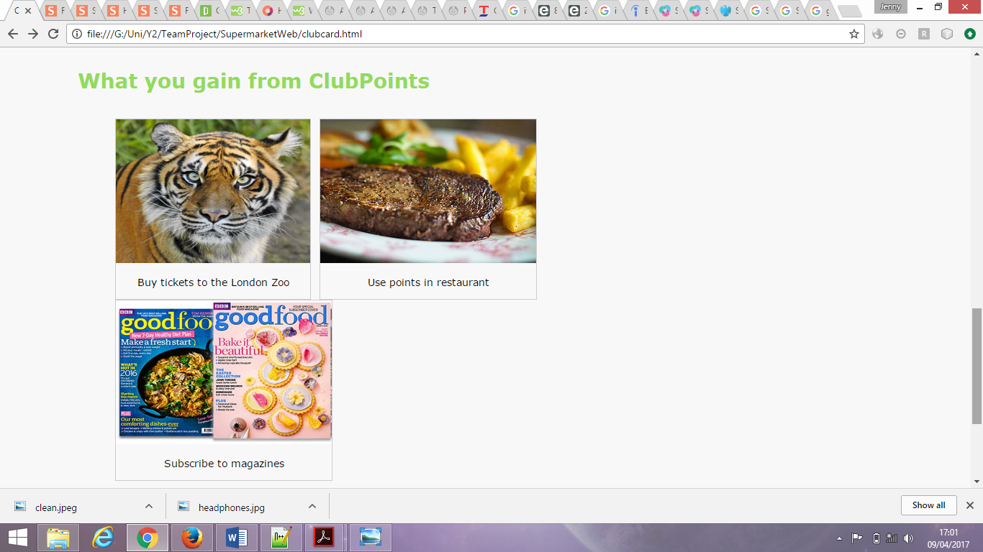

# **Nazir – Payment – Integration**

## **Integration Planner**

T

## **Sub Project Plan**

T

## **Risk Register**

The

## **Requirements**

T

**Payment Requirement**

* A customer should receive payment request when attempting to check out.
* Customer should receive a confirmation or denial for their payment.

## **Software**

E

## **Component Integration**

e

## **Testing**

E

# **Benjamin – Marketing - QA**

## **Quality Assurance**

Most of the time quality assurance is treats as the source of good quality in and of itself. That idea turns out to be unexpectedly imperfect one. After attractive our personal lumps on the subject of quality a few years back, we have a procession on the right way to gaze at it.

* Have we done what we promised?
* Have we done something that will make our customers happier?
* Have we done something that we will be proud of?

## **Sub Project Plan**

## **Risk Register**

The risk register contains the significant risks faced by the business and identifies the potential impact and likelihood at both a gross level (before consideration of mitigating controls) and net level (after consideration of mitigating controls). This gives the Board the opportunity to review the level of risk that the business is prepared to accept. The register also contains the assurance provided over current key mitigating controls. Where further actions have been identified to mitigate risks to a level deemed acceptable, these are agreed with specific timelines for delivery and are monitored closely until fully implemented.

## **Requirements**

Our team helps build relationships with both customers and colleagues. Internally, we communicate business news, shout about our success stories and inspire over 150,000 colleagues with our values, vision and goals. Externally, we speak to our customers constantly, enabling us to create targeted TV, online and radio campaigns, appealing in-store events and great sub-brands like Taste the Difference. Because we understand exactly what our customers want, we can find new ways to increase satisfaction, loyalty and sales.

**Marketing Requirements**

* User should be able to view the types of items purchased by a customer.
* User should be able to send recommendations/deals to customers.

## **Software**

The world is changing rapidly. Our vision is for FCEPH is to have a world-class digital and technology function to ensure that we can deliver great services for our customers whenever and wherever they want to shop with us.

This announcement demonstrates our commitment to that goal, and to attracting the best talent in this ever-developing sector. As Manchester is the UK’s second largest technology hub, it is a natural step for us to recruit there. It is a great time to be working in retail. This fast-paced, exciting sector is giving rise to the most innovative practices.

## **Component Integration**

* **Email Marketing.**   
  The most customizable, personalized and convenient way to market, email marketing allows you to constantly stay in touch with customers and keep them updated on your latest deals. [Email marketing](http://www.walsworth.com/blog/how-to-build-and-grow-your-email-list/) also enables you to track which recipients click on your links and ultimately make purchases, helping you to understand the tendencies of your best customers.
* **Banner Ads.**   
  Some feel the banner ad has gone out of style, but if you are looking for exposure, you could do a lot worse. Banner ads create awareness of your brand and help to facilitate inquiries by prospective customers. Additionally, through targeted advertising, you can make sure your banner ads are targeted to certain demographics at certain times so they are seen by those most likely to be interested in your product and when they are most likely to purchase.

## **Testing**

The market test is generally carried out to ascertain the probable market success in terms of new product’s performance, the level of acceptance of the product, customer satisfaction, and the efficiency of the marketing campaign.

# **Appendix**

## **Website**

### **Style.css**

@charset "utf-8";

/* CSS Document */

body {

font-family:Verdana, Geneva, sans-serif;

font-size:14px;

background-color:#FFFFFF;

margin: 0;

}

.utility {

z-index: 21;

position: relative;

height: 50px;

background-color:#FFFFFF;

border-bottom: 1px solid #DFDFDF;

left: 0;

right: 0;

top: 0;

margin: 0 auto;

box-sizing: content-box;

}

.utility_wrapper {

margin-left: 3%;

margin-right: 3%;

height: 50px;

}

.utility_nav1 {

float: left;

margin: 0px;

padding: 0px;

}

.utility_nav1 li a{

text-decoration: none;

color: #4E514E;

}

.utility_nav2 li a{

text-decoration: none;

color: #4E514E;

}

.utility_nav2 {

float: right;

margin: 0px;

padding: 0px;

text-decoration: none;

}

.utility_section {

float: right;

margin: 0px;

padding: 0px;

text-decoration: none;

}

.utility_option {

display: inline;

float: left;

padding-left: 10px;

padding-right: 10px;

padding-top: 10px;

height: inherit;

text-decoration: none;

}

/* Full-width input fields */

.container input[type=email], input[type=password] {

width: 100%;

padding: 12px 20px;

margin: 8px 0;

display: inline-block;

border: 1px solid #ccc;

box-sizing: border-box;

}

/* Set a style for all buttons */

button {

background-color: #91DC5A;

border-radius:25px;

color: white;

padding: 14px 20px;

margin: 8px 0;

border: none;

cursor: pointer;

width: 100%;

}

/* Extra styles for the cancel button */

.cancelbtn {

width: auto;

padding: 10px 18px;

background-color: #074DA3;

}

/* Center the image and position the close button */

.imgcontainer {

text-align: center;

margin: 24px 0 12px 0;

position: relative;

}

.container {

padding: 16px;

}

span.psw {

float: right;

padding-top: 16px;

}

span.reg {

float: right;

padding-bottom: 16px;

}

/* The Modal (background) */

.modal {

display: none; /* Hidden by default */

position: fixed; /* Stay in place */

z-index: 1; /* Sit on top */

left: 0;

top: 0;

width: 100%; /* Full width */

height: 100%; /* Full height */

overflow: auto; /* Enable scroll if needed */

background-color: rgb(0,0,0); /* Fallback color */

background-color: rgba(0,0,0,0.4); /* Black w/ opacity */

padding-top: 60px;

}

/* Modal Content/Box */

.modal-content {

background-color: #fefefe;

margin: 5% auto 15% auto; /* 5% from the top, 15% from the bottom and centered */

border: 1px solid #888;

width: 40%; /* Could be more or less, depending on screen size */

}

/* The Close Button (x) */

.close {

position: absolute;

right: 25px;

top: 0;

color: #000;

font-size: 35px;

font-weight: bold;

}

.close:hover,

.close:focus {

color: red;

cursor: pointer;

}

/* Add Zoom Animation */

.animate {

-webkit-animation: animatezoom 0.6s;

animation: animatezoom 0.6s

}

@-webkit-keyframes animatezoom {

from {-webkit-transform: scale(0)}

to {-webkit-transform: scale(1)}

}

@keyframes animatezoom {

from {transform: scale(0)}

to {transform: scale(1)}

}

/* Change styles for span and cancel button on extra small screens */

@media screen and (max-width: 300px) {

span.psw {

display: block;

float: none;

}

.cancelbtn {

width: 100%;

}

}

/* Remove margins and padding from the list */

.list{

margin: 0;

padding: 0;

}

/* Set all odd list items to a different color (zebra-stripes) */

.list li:nth-child(odd){

background: #f9f9f9;

}

.list li{

float:left;

position: relative;

padding: 12px 8px 12px 10px;

background: #eee;

transition: 0.2s;

}

.li {

border-bottom: solid 1px #DFDFDF;

}

.header {

border: solid 2px #DFDFDF;

}

#myUL ul{

display: table;

}

.list1 li{

float:left;

position: relative;

padding: 12px 8px 12px 10px;

background: #eee;

}

.sub-list1{

width: 60px;

height: inherited;

}

.sub-list2{

width: 600px;

height: inherited;

}

.sub-list3{

width: 60px;

height: inherited;

}

.sub-list4{

width: 40px;

height: inherited;

}

#myUL .li{

clear:both;

}

#myUL input {

border-radius: 15px;

border: solid 1px #DFDFDF;

padding: 10px;

width: 25px;

text-align: center;

}

/* Style the close button */

.close1 {

/*position: absolute;*/

right: 0;

padding: 12px 16px 12px 16px

}

.droo {

display: none;

position: absolute;

background-color: #f6f6f6;

min-width: 230px;

overflow: auto;

box-shadow: 0px 8px 16px 0px rgba(0,0,0,0.2);

z-index: 1;

margin-top:30px;

}

.droo a {

color: black;

padding: 12px 16px;

text-decoration: none;

display: block;

}

.show {display:block;}

.close1:hover {

background-color: #f44336;

color: white;

}

/* Style the tab */

.tab {

float: left;

border: 1px solid #ccc;

background-color: #f1f1f1;

width: 30%;

height: 400px;

border-right: none;

}

/* Style the buttons inside the tab */

.tab button {

display: block;

background-color: inherit;

color: black;

padding: 22px 16px;

width: 100%;

border: none;

outline: none;

text-align: left;

cursor: pointer;

transition: 0.3s;

font-size: 17px;

}

/* Change background color of buttons on hover */

.tab button:hover {

background-color: #ddd;

}

/* Create an active/current "tab button" class */

.tab button.active {

background-color: #ccc;

}

/* Style the tab content */

.tabcontent {

float: left;

padding: 0px 12px;

border: 1px solid #ccc;

width: 60%;

height: 600px;

}

#Info{

width:60%;

margin-top:0;

margin-bottom:0;

margin-right:8%;

}

header ul {

margin-left: 25px;

margin-right: 25px;

list-style:none;

padding:10px;

position:inherit;

letter-spacing: 1px;

display:block;

height:80px;

}

button.accordion {

background-color: #eee;

color: #444;

cursor: pointer;

padding: 18px;

width: 100%;

border: none;

text-align: left;

outline: none;

font-size: 15px;

transition: 0.4s;

}

button.accordion.active, button.accordion:hover {

background-color: #ddd;

}

button.accordion:after {

content: '\002B';

color: #777;

font-weight: bold;

float: right;

margin-left: 5px;

}

button.accordion.active:after {

content: "\2212";

}

div.panel {

padding: 0 18px;

background-color: white;

max-height: 0;

overflow: hidden;

transition: max-height 0.2s ease-out;

}

ul.breadcrumb {

padding: 10px 16px;

list-style: none;

background-color: #eee;

font-size: 17px;

}

ul.breadcrumb li {display: inline;}

ul.breadcrumb li+li:before {

padding: 8px;

color: black;

content: "/\00a0";

}

ul.breadcrumb li a {

color: #07198E;

text-decoration: none;

}

ul.breadcrumb li a:hover {

color: #01447e;

text-decoration: underline;

}

#h1{

float:left;

display:block;

}

#h2{

float:right;

display:block;

}

.drop{

margin-left: 10px;

margin-right: 10px;

}

.dropdown-content1 {

display: none;

position: absolute;

right: 0;

background-color: #FFFFFF;

z-index: 1;

padding-left: 15%;

padding-right: 15%;

border-top: 2px solid #91DC5A;

border-bottom: 1px solid #DFDFDF;

}

.dropdown-content1 a {

color: black;

padding: 12px 16px;

text-decoration: none;

display: block;

font-size: 12px;

}

.dropdown-content1 a:hover {text-decoration: underline;}

.drop:hover .dropdown-content1 {

display: block;

}

#search ul {

margin-top: 0px;

margin-right: auto;

margin-bottom: 0px;

margin-left: auto;

list-style:none;

padding:10px;

position:inherit;

letter-spacing: 1px;

display:table;

}

#search li {

float:left;

display:block;

padding-top:10px;

}

#search input {

Height:36px;

border-style: solid;

border-left:none;

border-right:none;

border-width:1px;

border-color:#C7CBC7;

padding-left: 12px;

}

#img {

border-style:solid;

border-left:none;

Height:34px;

border-bottom-right-radius:20px;

border-top-right-radius:20px;

border-width:1px;

border-color:#C7CBC7;

padding-right:10px;

padding-top:4px;

}

#img1 {

border-style:solid;

border-left:none;

Height:24px;

border-bottom-right-radius:20px;

border-top-right-radius:20px;

border-width:1px;

border-color:#C7CBC7;

padding-right:10px;

padding-top:4px;

}

#search select {

border-bottom-left-radius:20px;

border-top-left-radius:20px;

border-right:none;

border-style:solid;

border-width:1px;

border-color:#C7CBC7;

Height:40px;

text-align: center;

padding-left: 12px;

}

#search button {

border-radius: 100%;

border-style: solid;

background-color:#FFFFFF;

}

#search1 ul {

margin-top: 0px;

margin-right: auto;

margin-bottom: 0px;

margin-left: auto;

list-style:none;

position:inherit;

letter-spacing: 1px;

display:table;

}

#search1 li {

float:left;

display:block;

}

#search1 input {

Height:26px;

border-bottom-left-radius:20px;

border-top-left-radius:20px;

border-style: solid;

border-right:none;

border-width:1px;

border-color:#C7CBC7;

padding-left: 12px;

}

#search1 button {

border-radius: 50%;

border-style: solid;

}

nav ul {

margin-top: 0px;

margin-right: auto;

margin-bottom: 0px;

margin-left: auto;

list-style:none;

padding-top:10px;

position:inherit;

letter-spacing: 1px;

display:table;

}

nav li {

float:left;

display:block;

padding-top:15px;

padding-left:20px;

padding-right:20px;

border: 2px solid #FFFFFF;

border-bottom:none;

border-top-left-radius:15px;

border-top-right-radius:15px;

}

nav li a {

display:block;

width:inherit;

text-decoration:none;

text-align: middle;

color: #4E514E;

}

nav ul li.active {

border-color: #91DC5A;

}

nav ul li:hover {

border-color: #91DC5A;

}

#subnav ul {

margin-top: 0px;

margin-right: auto;

margin-bottom: 0px;

margin-left: auto;

list-style:none;

padding:10px;

position:inherit;

letter-spacing: 1px;

display:table;

}

#subnav li {

float:left;

display:block;

padding-left:10px;

padding-right:10px;

margin-left: 10px;

margin-right: 10px;

}

#subnav li a {

float:left;

display:block;

text-decoration:none;

}

.dropbtn {

font-size: 14px;

border: none;

cursor: pointer;

}

/* Dropdown button on hover & focus */

.dropbtn:hover, .dropbtn:focus {

color: #91DC5A;

}

/* The container <div> - needed to position the dropdown content */

.dropdown {

position: relative;

display: inline-block;

}

/* Dropdown Content (Hidden by Default) */

.dropdown-content {

float: left;

display: none;

position: absolute;

background-color: #fff;

margin-top: 18px;

min-width: 160px;

z-index: 1;

border: solid 1px #DFDFDF;

}

/* Links inside the dropdown */

.dropdown-content a {

color: black;

padding: 8px 16px;

text-decoration: none;

display: block;

border-bottom: solid 1px #DFDFDF;

width: 80%;

font-size: 12px;

clear: both;

}

/* Change color of dropdown links on hover */

.dropdown-content a:hover {color: #91DC5A}

/* Show the dropdown menu (use JS to add this class to the .dropdown-content container when the user clicks on the dropdown button) */

.show {display:block;}

#button button {

font-size:16px;

clear:both;

transition: background 0.5s ease-in-out 0s;

padding: 5px;

margin:0 auto;

}

header img {

border: 0px none;

}

header {

margin-left:60px;

margin-right:60px;

}

nav {

border-bottom: 2px solid #91DC5A;

min-height:44px;

font-size: 16px;

}

.mySlides {display:none}

/* Slideshow container */

.slideshow-container {

max-width: 80%;

position: relative;

margin: auto;

}

/* Next & previous buttons */

.prev, .next {

cursor: pointer;

position: absolute;

top: 50%;

width: auto;

padding: 16px;

margin-top: -22px;

color: white;

font-weight: bold;

font-size: 18px;

transition: 0.6s ease;

border-radius: 0 3px 3px 0;

}

/* Position the "next button" to the right */

.next {

right: 0;

border-radius: 3px 0 0 3px;

}

/* On hover, add a black background color with a little bit see-through */

.prev:hover, .next:hover {

background-color: rgba(0,0,0,0.8);

}

/* Caption text */

.text {

color: #f2f2f2;

font-size: 15px;

padding: 8px 12px;

position: absolute;

bottom: 8px;

width: 100%;

text-align: center;

background-color: rgba(0,0,0,0.8);

}

/* The dots/bullets/indicators */

.dot {

cursor:pointer;

height: 13px;

width: 13px;

margin: 0 2px;

background-color: #bbb;

border-radius: 50%;

display: inline-block;

transition: background-color 0.6s ease;

}

.active1, .dot:hover {

background-color: #717171;

}

/* Fading animation */

.fade {

-webkit-animation-name: fade;

-webkit-animation-duration: 1.5s;

animation-name: fade;

animation-duration: 1.5s;

}

@-webkit-keyframes fade {

from {opacity: .4}

to {opacity: 1}

}

@keyframes fade {

from {opacity: .4}

to {opacity: 1}

}

/* On smaller screens, decrease text size */

@media only screen and (max-width: 300px) {

.prev, .next,.text {font-size: 11px}

}

#tabs a{

text-decoration:none;

color:#000;

font-size: 1.1rem;

}

#tabs li{

float:left;

list-style:none;

padding:4px;

}

#tabs li{

background-color:#404040;

border-top-left-radius:5px;

border-top-right-radius:5px;

margin:5px;

}

#tabs {

clear:right;

}

#tabCtrl {

background-color:#181818;

padding:10px;

}

#AC ul li {

float: left;

list-style: none;

padding:50px;

}

#AC {

margin: 0 auto;

margin-top: -30px;

}

#AC li {

padding-left: 100px;

padding-right: 100px;

}

#to input{

Background-color: #0C0C0C;

color:#7e7e6b;

border: none;

Height:30px;

Width:150px;

font-size: 1.1rem;

font-family: "Open Sans",Arial,sans-serif;

text-align: center;

}

.floatright {

float:right;

margin-right:150px;

}

/* ---------- CALENDAR ---------- */

.calendar {

text-align: center;

}

.calendar header {

position: relative;

}

.calendar h2 {

text-transform: uppercase;

}

.calendar thead {

font-weight: 600;

text-transform: uppercase;

}

.calendar tbody {

color: #7c8a95;

}

.calendar tbody td:hover {

border: 2px solid #00addf;

}

.calendar td {

border: 2px solid transparent;

border-radius: 50%;

display: inline-block;

height: 4em;

line-height: 4em;

text-align: center;

width: 4em;

}

.calendar tbody td.checked {

background: #00addf;

color: #fff;

}

.calendar .prev-month,

.calendar .next-month {

color: #cbd1d2;

}

.calendar .prev-month:hover,

.calendar .next-month:hover {

border: 2px solid #cbd1d2;

}

.current-day {

background: #00addf;

color: #f9f9f9;

}

.event {

cursor: pointer;

position: relative;

}

.event:after {

background: #00addf;

border-radius: 50%;

bottom: .5em;

display: block;

content: '';

height: .5em;

left: 50%;

margin: -.25em 0 0 -.25em;

position: absolute;

width: .5em;

}

.event.current-day:after {

background: #f9f9f9;

}

.btn-prev,

.btn-next {

border: 2px solid #cbd1d2;

border-radius: 50%;

color: #cbd1d2;

height: 2em;

font-size: .75em;

line-height: 2em;

margin: -1em;

position: absolute;

top: 50%;

width: 2em;

}

.btn-prev:hover,

.btn-next:hover {

background: #cbd1d2;

color: #f9f9f9;

}

.btn-prev {

left: 6em;

}

.btn-next {

right: 6em;

}

.gridView li {

border: 1px solid #DFDFDF;

float: left;

height: 300px;

margin: 0 0 13px 13px;

padding: 0 0 10px 13px;

width: 189px;

background-color: #fff;

}

.js .gridView li {

height: auto;

}

.gridView li button{

width:75px;

}

.gridView li input{

border-radius:15px;

border:solid 1px #DFDFDF;

padding: 10px;

width:25px;

text-align:center;

}

.gridView li img{

padding-top: 10px;

}

#map{

width:650px;

margin:auto;

}

#filter{

max-width: 200px;

height: 60em;

}

#filter form{

width: 200px;

border:none;

}

#Product{

border: 0;

font: inherit;

margin: 0;

padding: 0;

vertical-align: baseline;

display: block;

}

#checkout{

display: table;

}

#content {

font-size:1.0em;

padding-left:8%;

padding-right:8%;

padding-top:5px;

padding-bottom:10px;

background-color:#F9F8F9;

}

#main {

display: table;

}

#main .responsive{

margin-top: 0;

margin-right: auto;

margin-bottom: 0;

margin-left: auto;

}

#Catagorys li{

padding-left: 10px;

border-bottom:1px solid;

border-color: #91DC5A;

text-decoration: none;

color: #000;

list-style:none;

}

#Catagorys ul{

padding-left: 0;

min-width: 250px;

}

ul, li{

list-style:none;

}

#Catagorys a{

text-decoration: none;

}

#Catagorys li:hover{

text-decoration: underline;

}

.img img:focus {

opacity: 0.5;

filter: alpha(opacity=50);

}

#itemDesc{

Border: 1px solid #DFDFDF;

width: 400px;

padding: 20px;

margin-top:80px;

}

#slider {

padding-left:75px;

padding-right:75px;

}

#content1 img{

padding-left:2%;

padding-right:2%;

}

.slideshow-container img {

margin: 13px;

border-radius: 5px;

height: 400px;

}

#find img {

border: 0px none;

}

#find img:hover {

transform: rotateY(360deg);

transition: all 1s ease 0s;

}

#faq{

display:block;

}

#contact {

margin:auto;

padding:10px;

display: table;

}

#title {

Padding: 10px;

clear: right;

width:200px;

padding-left: 50px;

}

#title select {

Width:100px;

Height:30px;

border-color:#000;

border:10px;

}

#fname {

Padding: 10px;

width:200px;

padding-left: 50px;

}

#fname input {

Width:100px;

Height:30px;

color:#7e7e6b;

border-color:#000;

border:10px;

}

#sname {

Padding: 10px;

width:200px;

float: right;

margin-top:-75px;

padding-right: 50px;

}

#sname input {

Width:100px;

Height:30px;

border-color:#000;

border-bottom-color:#262626;

border:10px;

}

#email {

Padding: 10px;

width:200px;

padding-left: 50px;

}

#email input {

Width:100px;

Height:30px;

border-color:#000;

border-bottom-color:#262626;

border:10px;

}

#phone {

Padding: 10px;

width:200px;

float: right;

margin-top:-75px;

padding-right: 50px;

}

#phone input {

Width:100px;

Height:30px;

border-color:#000;

border-bottom-color:#262626;

border:10px;

}

#subject {

Padding: 10px;

width:650px;

padding-left: 50px;

}

#message {

Padding: 10px;

width:650px;

padding-left: 50px;

}

#message textarea{

Width:350px;

Height:100px;

border-color:#000;

border-bottom-color:#262626;

border:10px;

resize: vertical;

}

div.img {

border: 1px solid #ccc;

}

div.img:hover {

border: 1px solid #777;

}

div.img img {

}

div.desc {

padding: 15px;

text-align: center;

}

.responsive {

padding: 0 6px;

float: left;

}

@media only screen and (max-width: 700px){

.responsive {

margin: 6px 0;

}

}

@media only screen and (max-width: 500px){

.responsive {

width: 100%;

}

}

.clearfix:after {

content: "";

display: table;

clear: both;

}

.center {

max-width: 900px;

text-align: center;

margin: auto;

display: table;

}

.center1 {

max-width: 170px;

text-align: center;

margin: auto;

}

.center2{

max-width: 900px;

text-align: center;

margin: auto;

display:table;

}

.pagination{

z-index: 21;

box-sizing: content-box;

height:50px;

clear:both;

}

.pagination a {

color: black;

float: left;

padding: 8px 16px;

text-decoration: none;

transition: background-color .3s;

}

.pagination a.active1 {

background-color: #91DC5A;

color: white;

}

.pagination a:hover:not(.active1) {background-color: #ddd;}

footer {

background-color:#0D0936;

color:#FFFFFF;

text-decoration:none;

clear:both;

}

footer ul {

margin-top: 1px;

margin-right: auto;

margin-bottom: 0px;

margin-left: auto;

padding:10px;

letter-spacing:1px;

display:table;

}

#sub li{

display:block;

color:#FFFFFF;

border-bottom: 2px solid;

border-color:#0D0936;

}

#sub li a{

text-decoration:none;

color:#FFFFFF;

}

#sub li:hover {

border-color:#FFFFFF;

}

#bottom {

margin-left:550px;

padding:10px;

}

.Enquiry {

width: 60%;

border-radius:5px;

border: 1px solid #DFDFDF;

}

.Enquiry p {

font-size: 1.4rem;

padding: 10px;

}

#find {

float:right;

padding:10px;

}

#find img {

margin-left:2px;

margin-right:2px;

}

### **Index.html**

<!doctype html>

<html>

<head>

<meta charset="utf-8">

<title>FCEPH</title>

<link href="css/style.css" rel="stylesheet" type="text/css" />

<script>

// Get the modal

var modal = document.getElementById('id01');

// When the user clicks anywhere outside of the modal, close it

window.onclick = function(event) {

if (event.target == modal) {

modal.style.display = "none";

}

}

</script>

</head>

<body>

<div class="utility">

<div class="utility_wrapper">

<ul class="utility_nav1">

<li class="utility_option"><a href="help.html" class="utility_option_link"><img src="images/help.png" width="20" height="21" alt="Locator" /><span> Help</span></a></li>

</ul>

<ul class="utility_nav2">

<li class="utility_option"><a href="#" class="utility_option_link" onclick="document.getElementById('id01').style.display='block'"><img src="images/account.png" width="20" height="21" alt="Locator" /><span> Sign in/Register</span></a></li>

<div id="id01" class="modal">

<form class="modal-content animate" action="account.html">

<div class="imgcontainer">

<span onclick="document.getElementById('id01').style.display='none'" class="close" title="Close Modal">&times;</span>

</div>

<div class="container">

<label><b>Email</b></label>

<input type="email" placeholder="Enter Email" name="uname" required>

<label><b>Password</b></label>

<input type="password" placeholder="Enter Password" name="psw" required>

<button type="submit">Login</button>

<input type="checkbox" checked="checked"> Remember me

<span class="reg"><a href="signup.html">New Customer?</a></span>

</div>

<div class="container" style="background-color:#f1f1f1">

<button type="button" onclick="document.getElementById('id01').style.display='none'" class="cancelbtn">Cancel</button>

<span class="psw"><a href="#">Forgot password?</a></span>

</div>

</form>

</div>

</ul>

</div>

</div><!--End of utility-->

<div id="wrapper">

<header>

<ul>

<li id="h1"><a href="index.html"><img src="images/logo.png" width="227" height="99" alt="logo" /></a></li>

<!--This will be our logo which will be a link to the home page-->

</ul>

</header> <!--End of header-->

<nav>

<ul>

<div class="drop" style="float:left;"><li ><a href="groceries.html">Groceries</a>

<div class="dropdown-content1" style="left:0;">

<a href="groceries.html" style="float:left">All Groceries</a>

<a href="#" style="float:right" ><img src="images/recipe.jpg" width="600" height="200" alt="Recipes"/></a>

<a href="freshfood.html" style="Clear: left">Fresh Food</a>

<a href="bakery.html" style="Clear: left">Bakery</a>

<a href="foodcupboard.html" style="Clear: left">Food Cupboard</a>

<a href="ghousehold.html" style="Clear: left">Household</a>

</div>

</li></div>

<div class="drop" style="float:left;"><li><a href="clothing.html">Clothing</a>

<div class="dropdown-content1" style="left:0;">

<a href="clothing.html" style="float:left">All Clothing </a>

<a href="#" style="float:right" style="Clear: both"><img src="images/getimage.jpg" width="600" height="200" alt="Spring Time Clothing"/></a>

<a href="woman.html" style="Clear: left">Women</a>

<a href="man.html" style="Clear: left">Men</a>

<a href="kids.html" style="Clear: left">Kids</a>

<a href="babyc.html" style="Clear: left">Baby</a>

</div>

</li></div>

<div class="drop" style="float:left;"><li><a href="electronics.html">Electronics</a>

<div class="dropdown-content1" style="left:0;">

<a href="electronics.html" style="float:left">All Electronics</a>

<a href="#" style="float:right" style="Clear: both"><img src="images/recipes1.png" width="600" height="200" alt="Home Cinema"/></a>

<a href="#" style="Clear: left">Household Appliances</a>

<a href="#" style="Clear: left">Heating & Cooling</a>

<a href="#" style="Clear: left">Laptop & PCs</a>

<a href="#" style="Clear: left">Personal Electrical</a>

</div>

</li></div>

<div class="drop" style="float:left;"><li><a href="pharmacy.html">Pharmacy</a>

<div class="dropdown-content1" style="left:0;">

<a href="#" style="float:left">All Pharmacy</a>

<a href="#"style="float:right" style="Clear: both"><img src="images/recipes1.png" width="600" height="200" alt="Vitamins"/></a>

<a href="#"style="Clear: left">Health & Pharmacy</a>

<a href="#"style="Clear: left">Beauty & Skincare</a>

<a href="#"style="Clear: left">Fragrance</a>

<a href="#"style="Clear: left">Baby & Child</a>

</div>

</li></div>

<div class="drop" style="float:left;"><li><a href="household.html">Home & Furniture</a>

<div class="dropdown-content1" style="left:0;">

<a href="household.html" style="float:left">All Home & Furniture</a>

<a href="#"style="float:right" style="Clear: both"><img src="images/elgar-free-delivery.jpg" width="600" height="200" alt="Spring"/></a>

<a href="#"style="Clear: left">Living Room</a>

<a href="#"style="Clear: left">Bedroom</a>

<a href="#"style="Clear: left">Home Accessories</a>

<a href="#"style="Clear: left">Lighting</a>

</div>

</li></div>

<div class="drop" style="float:left;"><li><a href="clubcard.html">Clubcard</a>

</li></div>

</ul>

</nav><!--End of navigation-->

<div id="intro" style="background-color:#F9F8F9;">

<div class="slideshow-container">

<div class="mySlides fade">

<img src="images/clothes.jpg" style="width:100%">

<div class="text">Clothes for .......</div>

</div>

<div class="mySlides fade">

<img src="images/house.png" style="width:100%">

<div class="text">Furnish your house with our</div>

</div>

<div class="mySlides fade">

<img src="images/food.jpg" style="width:100%">

<div class="text">Fresh Gorceries</div>

</div>

<div class="mySlides fade">

<img src="images/elec.jpg" style="width:100%">

<div class="text">Electronics </div>

</div>

<a class="prev" onclick="plusSlides(-1)">&#10094;</a>

<a class="next" onclick="plusSlides(1)">&#10095;</a>

</div>

<br>

<div style="text-align:center">

<span class="dot" onclick="currentSlide(1)"></span>

<span class="dot" onclick="currentSlide(2)"></span>

<span class="dot" onclick="currentSlide(3)"></span>

<span class="dot" onclick="currentSlide(4)"></span>

</div>

<!--Slider of pictures about different products-->

<script>

var slideIndex = 1;

showSlides(slideIndex);

function plusSlides(n) {

showSlides(slideIndex += n);

}

function currentSlide(n) {

showSlides(slideIndex = n);

}

var slideIndex = 0;

showSlides();

function showSlides() {

var i;

var slides = document.getElementsByClassName("mySlides");

for (i = 0; i < slides.length; i++) {

slides[i].style.display = "none";

}

slideIndex++;

if (slideIndex> slides.length) {slideIndex = 1}

slides[slideIndex-1].style.display = "block";

setTimeout(showSlides, 5000); // Change image every 5 seconds

}

</script>

</div><!--End of intro-->

<div id="content" >

<h2 style="text-align:center; color:#91DC5A;"> More from FCEPH </h2>

<div class="center">

<div class="responsive">

<div class="img">

<img src="images/health.jpg" alt="Health" width="270" height="170">

<div class="desc">Add a description of the image here</div>

</div></div>

<div class="responsive">

<div class="img">

<img src="images/recipes.jpg" alt="Recipes" width="270" height="170">

<div class="desc">Add a description of the image here</div>

</div></div>

<div class="responsive">

<div class="img">

<img src="images/Save.jpg" alt="Savings" width="270" height="170">

<div class="desc">Add a description of the image here</div>

</div></div>

</div>

</div><!--End of content-->

<footer>

<ul>

<li>

<h4>FCEPH Help & FAQ</h4>

<ul id="sub">

<li><a href="contact.html">Help Centre</a></li>

<li><a href="contact.html#a">Contact Us</a></li>

</ul>

</li>

</ul>

</footer><!--End of footer-->

<div id="copy" style="padding-top:15px; float:left; padding-left:15px">&copyFCEHP 2017 All Rights Reserved</div>

<div id="find">Follow us: <a href="https://plus.google.com/"><img src="images/google.png" width="20" height="21" alt="google" /></a>

<a href="https://facebook.com/"><img src="images/facebook.png" width="20" height="21" alt="Facebook" /></a>

<a href="https://twitter.com/"><img src="images/twitter.png" width="20" height="21" alt="Twitter" /></a>

<a href="https://youtube.com/"><img src="images/youtube.png" width="20" height="21" alt="Youtube" /></a></div>

<!--Youtube, Facebook, Twitter and other links-->

</div> <!--End of wrapper-->

</body>

</html>

### **item.html**

<!doctype html>

<html>

<head>

<meta charset="utf-8">

<title>Item | FCEPH</title>

<link href="css/style.css" rel="stylesheet" type="text/css" />

<script> function Drop1() {

document.getElementById("myDropdown").classList.toggle("show");

}

function Drop2() {

document.getElementById("myDropdown2").classList.toggle("show");

}

function Drop3() {

document.getElementById("myDropdown3").classList.toggle("show");

}

function Drop4() {

document.getElementById("myDropdown4").classList.toggle("show");

}

function Drop5() {

document.getElementById("myDropdown5").classList.toggle("show");

}

function Drop6() {

document.getElementById("myDropdown6").classList.toggle("show");

}

function Drop7() {

document.getElementById("myDropdown7").classList.toggle("show");

}

function Drop8() {

document.getElementById("myDropdown8").classList.toggle("show");

}

// Close the dropdown menu if the user clicks outside of it

window.onclick = function (event) {

if (!event.target.matches('.dropbtn')) {

var dropdowns = document.getElementsByClassName("dropdown-content");

var i;

for (i = 0; i < dropdowns.length; i++) {

var openDropdown = dropdowns[i];

if (openDropdown.classList.contains('show')) {

openDropdown.classList.remove('show');

}

}

}

}</script>

<script src="basket.js"></script>

</head>

<body>

<div class="utility">

<div class="utility_wrapper">

<ul class="utility_nav2">

<li class="utility_option"><a href="account.html" class="utility_option_link"><img src="images/account.png" width="20" height="21" alt="Account" /><span> Your Account</span></a></li>

<li class="utility_option"><a onclick="document.getElementById('id01').style.display = 'block'" class="utility_option_link"><img src="images/basket.png" width="20" height="21" alt="Basket" /><span> Your Basket</span></a></li>

<div id="id01" class="modal">

<form class="modal-content animate" action="delivery.html">

<div class="imgcontainer">

<span onclick="document.getElementById('id01').style.display = 'none'" class="close" title="Close Modal">&times;</span>

</div>

<div class="container">

<div style="width:350px; margin:auto;">

<table cellpadding="4" cellspacing="4" border="1">

<tr>

<td valign="top">

<table cellpadding="4" cellspacing="4" id="orderedProductsTbl">

<thead>

<tr>

<td>

Name

</td>

<td>

Description

</td>

<td>

Quantity

</td>

<td>

Price

</td>

</tr>

</thead>

<tbody id="orderedProductsTblBody">

</tbody>

<tfoot>

<tr>

<td colspan="4" align="right" id="cart_total">

</td>

</tr>

</tfoot>

</table>

</td>

</tr>

</table>

</div>

</div>

<div class="container" style="background-color:#f1f1f1">

<button type="button" onclick="document.getElementById('id01').style.display = 'none'" class="cancelbtn">Cancel</button>

<span class="psw" style="margin-top:-20px;"><button> Checkout</button></span>

</div>

</form>

</div>

</ul>

</div>

</div>

<div id="wrapper">

<header>

<ul>

<a href="index.html"><img src="images/logo.png" width="227" height="99" alt="logo" /></a>

</ul>

</header>

<nav>

<ul>

<li style="margin-left: 10px; margin-right: 10px;"><a href="groceries.html">Groceries</a></li>

<li style="margin-left: 10px; margin-right: 10px;"><a href="clothing.html">Clothing</a></li>

<li style="margin-left: 10px; margin-right: 10px;"><a href="electronics.html">Electronics</a></li>

<li style="margin-left: 10px; margin-right: 10px;"><a href="pharmacy.html">Pharmacy</a></li>

<li style="margin-left: 10px; margin-right: 10px;"><a href="household.html">Home & Furniture</a></li>

<li style="margin-left: 10px; margin-right: 10px;"><a href="clubcard.html">Clubcard</a></li>

</ul>

</nav><!--End of navigation-->

<div id="subnav">

<ul>

<li><div class="dropdown">

<a onclick="Drop1()" class="dropbtn">Fresh Food</a>

<div id="myDropdown" class="dropdown-content">

<a href="freshfood.html">All Fresh Food</a>

<a href="fruit.html">Fresh Fruit & Veg</a>

<a href="salads.html">Salads</a>

<a href="dips.html">Coleslaw & Dips</a>

<a href="milk.html">Milk, Eggs, Cheese & Butter</a>

<a href="yoghurts.html">Yoghurts</a>

<a href="dairyfree.html">Dairy Alternatives</a>

<a href="freshmeat.html">Fresh Meat & Poultry</a>

<a href="fish.html">Fish & Seafood</a>

<a href="cookedmeat.html">Cooked Meats & Sandwich Fillers</a>

</div></div></li>

<li><div class="dropdown">

<a onclick="Drop2()" class="dropbtn">Bakery</a>

<div id="myDropdown2" class="dropdown-content">

<a href="bakery.html">All Bakery</a>

<a href="bread.html">Bread & Rolls</a>

<a href="wraps.html">Wraps, Naan & Pittas</a>

<a href="pancake.html">Pancake</a>

<a href="muffins.html">Muffins & Crumpets</a>

<a href="croissants.html">Croissants & Brioche</a>

<a href="scones.html">Scones & Teacake</a>

<a href="donut.html">Doughnuts & Cookies</a>

<a href="cake.html">Cake & Pies</a>

</div></div></li>

<li><div class="dropdown">

<a onclick="Drop3()" class="dropbtn">Frozen Food</a>

<div id="myDropdown3" class="dropdown-content">

<a href="frozenfood.html">All Frozen Food</a>

<a href="fmeat.html">Frozen Meat & Poultry</a>

<a href="ffish.html">Frozen Fish & Seafood</a>

<a href="ice.html">Ice Cream, Ice Lollies & Frozen Yoghurt</a>

<a href="fdesserts.html">Frozen Desserts</a>

<a href="fpizza.html">Frozen Pizza</a>

<a href="fchips.html">Frozen Chips & Potatoes</a>

<a href="fpudding.html">Frozen Puddings</a>

<a href="fpies.html">Frozen Pies</a>

</div></div></li>

<li><div class="dropdown">

<a onclick="Drop4()" class="dropbtn">Food Cupboard</a>

<div id="myDropdown4" class="dropdown-content">

<a href="foodcupboard.html">All Food Cupboard</a>

<a href="tins.html">Tins, Cans & Packets</a>

<a href="biscuits.html">Biscuits</a>

<a href="crisps.html">Crisps, Snacks & Nuts</a>

<a href="chocolate.html">Chocolate</a>

<a href="sweets.html">Sweets, Mints & Chewing Gum</a>

<a href="cereal.html">Cereal</a>

<a href="cooking.html">Cooking Ingredients</a>

<a href="pasta.html">Spaghetti, Pasta, Rice & Noodles</a>

<a href="baking.html">Home Baking</a>

<a href="jam.html">Jams & Spreads</a>

</div></div></li>

<li><div class="dropdown">

<a onclick="Drop5()" class="dropbtn">Drinks</a>

<div id="myDropdown5" class="dropdown-content">

<a href="drinks.html">All Drinks</a>

<a href="fizzy.html">Fizzy Drinks</a>

<a href="juice.html">Juice & Smoothies</a>

<a href="squash.html">Squash</a>

<a href="kdrink.html">Kids</a>

<a href="water.html">Bottled Water</a>

<a href="energy.html">Sports & Energy Drinks</a>

<a href="milkshake.html">Milkshake</a>

<a href="tea.html">Tea</a>

<a href="coffee.html">Coffee</a>

<a href="wine.html">Wine</a>

<a href="beer.html">Beer & Cider</a>

</div></div></li>

<li><div class="dropdown">

<a onclick="Drop6()" class="dropbtn">Household</a>

<div id="myDropdown6" class="dropdown-content">

<a href="ghousehold.html">All Household</a>

<a href="laundry.html">Laundry</a>

<a href="toiletr.html">Toilet Roll</a>

<a href="kitchenr.html">Kitchen Roll</a>

<a href="tissues.html">Tissues</a>

<a href="cleaning.html">Cleaning</a>

<a href="dishwasher.html">Dishwasher</a>

<a href="air.html">Air Fresheners</a>

<a href="gstorage.html">Food Storage</a>

<a href="lightbulb.html">Lightbulbs</a>

<a href="batteries.html">Batteries</a>

</div></div></li>

<li><div class="dropdown">

<a onclick="Drop7()" class="dropbtn">Baby</a>

<div id="myDropdown7" class="dropdown-content">

<a href="baby.html">All Baby</a>

<a href="nappies.html">Nappies & Pants</a>

<a href="bwipes.html">Baby & Toddler Wipes</a>

<a href="btoilet.html">Baby & Toddler Toiletries</a>

<a href="bhealth.html">Baby & Toddler Healthcare</a>

<a href="bmilk.html">Baby & Toddler Milk</a>

<a href="bfood.html">Baby & Toddler Food</a>

<a href="bfeed.html">Feeding Accessories</a>

<a href="bsteril.html">Sterilisers & Sterilants</a>

<a href="bsooth.html">Soothers & Teethers</a>

<a href="blaundry.html">Baby Laundry</a>

</div></div></li>

<li><div class="dropdown">

<a onclick="Drop8()" class="dropbtn">Pets</a>

<div id="myDropdown8" class="dropdown-content">

<a href="pets.html">All Pets</a>

<a href="cat.html">Cat & Kitten Food, Treats & Accessories</a>

<a href="dog.html">Dog & Puppy Food, Treats & Accessories</a>

<a href="animal.html">Small Animal, Fish & Bird</a>

</div></div></li>

</ul>

</div><!--End of subnavigation-->

<div id="content">

<div id="intro1">

<ul class="breadcrumb">

<li><a href="groceries.html">Groceries</a></li>

<li><a href="freshfood.html">Fresh Foods</a></li>

<li><a href="fruit.html">Fresh Fruit</a></li>

</ul>

</div><!--End of intro-->

<div id="main">

<div id="item" style="float:left">

<h2 style="float: left">Red Seedless Grapes 500g</h2><br>

<img src="images/media_889001_L.jpg" width="270" height="170" alt="Apple" />

<div >

<p>£1.75</p>

<input type="text" value="1" name="quantity"/>

</div>

</div>

<div id="itemDesc" style="float:right" width="400">

<p>Country of Origin

Grown in Brazil, Chile, Egypt, Greece, India, Israel, Italy, Lebanon,

Morocco, Namibia, Peru, Portugal, South Africa, Spain, USA, Zambia

<br><br>

Size

500gg</p>

</div><div style="width:100;"><button type="submit">Add</button></div>

</div>

</div><!--End of content-->

<footer>

<ul>

<li>

<h4>FCEPH Help & FAQ</h4>

<ul id="sub">

<li><a href="contact.html">Help Centre</a></li>

<li><a href="map.html">Store Locator</a></li>

<li><a href="contact.html#a">Contact Us</a></li>

</ul>

</li>

</ul>

</footer><!--End of footer-->

<div id="copy" style="padding-top:15px; float:left; padding-left:15px">&copyFCEHP 2017 All Rights Reserved</div>

<div id="find">Follow us: <a href="https://plus.google.com/"><img src="images/google.png" width="20" height="21" alt="google" /></a>

<a href="https://facebook.com/"><img src="images/facebook.png" width="20" height="21" alt="Facebook" /></a>

<a href="https://twitter.com/"><img src="images/twitter.png" width="20" height="21" alt="Twitter" /></a>

<a href="https://youtube.com/"><img src="images/youtube.png" width="20" height="21" alt="Youtube" /></a></div>

</div> <!--End of wrapper-->

</body>

</html>

### **Groceries.html**

<!doctype html>

<html>

<head>

<meta charset="utf-8">

<title>Groceries | FCEPH</title>

<link href="css/style.css" rel="stylesheet" type="text/css" />

<script> function Drop1() {

document.getElementById("myDropdown").classList.toggle("show");

}

function Drop2() {

document.getElementById("myDropdown2").classList.toggle("show");

}

function Drop3() {

document.getElementById("myDropdown3").classList.toggle("show");

}

function Drop4() {

document.getElementById("myDropdown4").classList.toggle("show");

}

function Drop5() {

document.getElementById("myDropdown5").classList.toggle("show");

}

function Drop6() {

document.getElementById("myDropdown6").classList.toggle("show");

}

function Drop7() {

document.getElementById("myDropdown7").classList.toggle("show");

}

function Drop8() {

document.getElementById("myDropdown8").classList.toggle("show");

}

// Close the dropdown menu if the user clicks outside of it

window.onclick = function(event) {

if (!event.target.matches('.dropbtn')) {

var dropdowns = document.getElementsByClassName("dropdown-content");

var i;

for (i = 0; i < dropdowns.length; i++) {

var openDropdown = dropdowns[i];

if (openDropdown.classList.contains('show')) {

openDropdown.classList.remove('show');

}

}

}

}</script>

</head>

<body>

<div class="utility">

<div class="utility_wrapper">

<ul class="utility_nav2">

<li class="utility_option"><a href="account.html" class="utility_option_link"><img src="images/account.png" width="20" height="21" alt="Account" /><span> Your Account</span></a></li>

<li class="utility_option"><a onclick="document.getElementById('id01').style.display = 'block'" class="utility_option_link"><img src="images/basket.png" width="20" height="21" alt="Basket" /><span> Your Basket</span></a></li>

<div id="id01" class="modal">

<form class="modal-content animate" action="delivery.html">

<div class="imgcontainer">

<span onclick="document.getElementById('id01').style.display = 'none'" class="close" title="Close Modal">&times;</span>

</div>

<div class="container">

<div style="width:350px; margin:auto;">

<table cellpadding="4" cellspacing="4" border="1">

<tr>

<td valign="top">

<table cellpadding="4" cellspacing="4" id="orderedProductsTbl">

<thead>

<tr>

<td>

Name

</td>

<td>

Description

</td>

<td>

Quantity

</td>

<td>

Price

</td>

</tr>

</thead>

<tbody id="orderedProductsTblBody">

</tbody>

<tfoot>

<tr>

<td colspan="4" align="right" id="cart_total">

</td>

</tr>

</tfoot>

</table>

</td>

</tr>

</table>

</div>

</div>

<div class="container" style="background-color:#f1f1f1">

<button type="button" onclick="document.getElementById('id01').style.display = 'none'" class="cancelbtn">Cancel</button>

<span class="psw" style="margin-top:-20px;"><button> Checkout</button></span>

</div>

</form>

</div>

</ul>

</div>

</div>

<div id="wrapper">

<header>

<ul>

<a href="index.html"><img src="images/logo.png" width="227" height="99" alt="logo" /></a>

</ul>

</header>

<nav>

<ul>

<li class="active" style="margin-left: 10px; margin-right: 10px;"><a href="groceries.html">Groceries</a></li>

<li style="margin-left: 10px; margin-right: 10px;"><a href="clothing.html">Clothing</a></li>

<li style="margin-left: 10px; margin-right: 10px;"><a href="electronics.html">Electronics</a></li>

<li style="margin-left: 10px; margin-right: 10px;"><a href="pharmacy.html">Pharmacy</a></li>

<li style="margin-left: 10px; margin-right: 10px;"><a href="household.html">Home & Furniture</a></li>

<li style="margin-left: 10px; margin-right: 10px;"><a href="clubcard.html">Clubcard</a></li>

</ul>

</nav><!--End of navigation-->

<div id="subnav">

<ul>

<li><div class="dropdown">

<a onclick="Drop1()" class="dropbtn">Fresh Food</a>

<div id="myDropdown" class="dropdown-content">

<a href="freshfood.html">All Fresh Food</a>

<a href="fruit.html">Fresh Fruit & Veg</a>

<a href="salads.html">Salads</a>

<a href="dips.html">Coleslaw & Dips</a>

<a href="milk.html">Milk, Eggs, Cheese & Butter</a>

<a href="yoghurts.html">Yoghurts</a>

<a href="dairyfree.html">Dairy Alternatives</a>

<a href="freshmeat.html">Fresh Meat & Poultry</a>

<a href="fish.html">Fish & Seafood</a>

<a href="cookedmeat.html">Cooked Meats & Sandwich Fillers</a>

</div></div></li>

<li><div class="dropdown">

<a onclick="Drop2()" class="dropbtn">Bakery</a>

<div id="myDropdown2" class="dropdown-content">

<a href="bakery.html">All Bakery</a>

<a href="bread.html">Bread & Rolls</a>

<a href="wraps.html">Wraps, Naan & Pittas</a>

<a href="pancake.html">Pancake</a>

<a href="muffins.html">Muffins & Crumpets</a>

<a href="croissants.html">Croissants & Brioche</a>

<a href="scones.html">Scones & Teacake</a>

<a href="donut.html">Doughnuts & Cookies</a>

<a href="cake.html">Cake & Pies</a>

</div></div></li>

<li><div class="dropdown">

<a onclick="Drop3()" class="dropbtn">Frozen Food</a>

<div id="myDropdown3" class="dropdown-content">

<a href="frozenfood.html">All Frozen Food</a>

<a href="fmeat.html">Frozen Meat & Poultry</a>

<a href="ffish.html">Frozen Fish & Seafood</a>

<a href="ice.html">Ice Cream, Ice Lollies & Frozen Yoghurt</a>

<a href="fdesserts.html">Frozen Desserts</a>

<a href="fpizza.html">Frozen Pizza</a>

<a href="fchips.html">Frozen Chips & Potatoes</a>

<a href="fpudding.html">Frozen Puddings</a>

<a href="fpies.html">Frozen Pies</a>

</div></div></li>

<li><div class="dropdown">

<a onclick="Drop4()" class="dropbtn">Food Cupboard</a>

<div id="myDropdown4" class="dropdown-content">

<a href="foodcupboard.html">All Food Cupboard</a>

<a href="tins.html">Tins, Cans & Packets</a>

<a href="biscuits.html">Biscuits</a>

<a href="crisps.html">Crisps, Snacks & Nuts</a>

<a href="chocolate.html">Chocolate</a>

<a href="sweets.html">Sweets, Mints & Chewing Gum</a>

<a href="cereal.html">Cereal</a>

<a href="cooking.html">Cooking Ingredients</a>

<a href="pasta.html">Spaghetti, Pasta, Rice & Noodles</a>

<a href="baking.html">Home Baking</a>

<a href="jam.html">Jams & Spreads</a>

</div></div></li>

<li><div class="dropdown">

<a onclick="Drop5()" class="dropbtn">Drinks</a>

<div id="myDropdown5" class="dropdown-content">

<a href="drinks.html">All Drinks</a>

<a href="fizzy.html">Fizzy Drinks</a>

<a href="juice.html">Juice & Smoothies</a>

<a href="squash.html">Squash</a>

<a href="kdrink.html">Kids</a>

<a href="water.html">Bottled Water</a>

<a href="energy.html">Sports & Energy Drinks</a>

<a href="milkshake.html">Milkshake</a>

<a href="tea.html">Tea</a>

<a href="coffee.html">Coffee</a>

<a href="wine.html">Wine</a>

<a href="beer.html">Beer & Cider</a>

</div></div></li>

<li><div class="dropdown">

<a onclick="Drop6()" class="dropbtn">Household</a>

<div id="myDropdown6" class="dropdown-content">

<a href="ghousehold.html">All Household</a>

<a href="laundry.html">Laundry</a>

<a href="toiletr.html">Toilet Roll</a>

<a href="kitchenr.html">Kitchen Roll</a>

<a href="tissues.html">Tissues</a>

<a href="cleaning.html">Cleaning</a>

<a href="dishwasher.html">Dishwasher</a>

<a href="air.html">Air Fresheners</a>

<a href="gstorage.html">Food Storage</a>

<a href="lightbulb.html">Lightbulbs</a>

<a href="batteries.html">Batteries</a>

</div></div></li>

<li><div class="dropdown">

<a onclick="Drop7()" class="dropbtn">Baby</a>

<div id="myDropdown7" class="dropdown-content">

<a href="baby.html">All Baby</a>

<a href="nappies.html">Nappies & Pants</a>

<a href="bwipes.html">Baby & Toddler Wipes</a>

<a href="btoilet.html">Baby & Toddler Toiletries</a>

<a href="bhealth.html">Baby & Toddler Healthcare</a>

<a href="bmilk.html">Baby & Toddler Milk</a>

<a href="bfood.html">Baby & Toddler Food</a>

<a href="bfeed.html">Feeding Accessories</a>

<a href="bsteril.html">Sterilisers & Sterilants</a>

<a href="bsooth.html">Soothers & Teethers</a>

<a href="blaundry.html">Baby Laundry</a>

</div></div></li>

<li><div class="dropdown">

<a onclick="Drop8()" class="dropbtn">Pets</a>

<div id="myDropdown8" class="dropdown-content">

<a href="pets.html">All Pets</a>

<a href="cat.html">Cat & Kitten Food, Treats & Accessories</a>

<a href="dog.html">Dog & Puppy Food, Treats & Accessories</a>

<a href="animal.html">Small Animal, Fish & Bird</a>

</div></div></li>

</ul>

</div><!--End of subnavigation-->

<div id="content">

<div id="intro1">

<h2>Groceries</h2>

<p>Lorem ipsum dolor sit amet, consectetur adipiscing elit. Ut consectetur arcu eget est ornare, at commodo purus blandit.

Ut magna risus, ultricies sed ex in, aliquet iaculis lectus. In non maximus ligula, sit amet tincidunt elit. </p>

</div><!--End of intro-->

<div id="main">

<div class="responsive">

<div class="img">

<a target="_blank" href="#">

<img src="f.jpg" alt="m" width="800" height="400">

</a>

<div class="desc">Now offers fresh groceries delivered twice weekly</div>

</div>

</div>

<div class="responsive" style="float:right" style="margin-top:-10px">

<div class="img">

<a target="_blank" href="#">

<img src="images/free-groceries.jpg" alt="m" width="300" height="200">

</a>

<div class="desc">Balanced diet based on raw organic <br>vegetables</div>

</div>

</div>

<div class="responsive" style="float:right">

<div class="img">

<a target="_blank" href="#">

<img src="images/groceriesben.jpg" alt="m" width="300" height="200">

</a>

<div class="desc">Wicker basket with assorted organic <br>vegetables and fruits isolated on white</div>

</div>

</div>

</div>

</div><!--End of content-->

<footer>

<ul>

<li>

<h4>FCEPH Help & FAQ</h4>

<ul id="sub">

<li><a href="contact.html">Help Centre</a></li>

<li><a href="map.html">Store Locator</a></li>

<li><a href="contact.html#a">Contact Us</a></li>

</ul>

</li>

</ul>

</footer><!--End of footer-->

<div id="copy" style="padding-top:15px; float:left; padding-left:15px">&copyFCEHP 2017 All Rights Reserved</div>

<div id="find">Follow us: <a href="https://plus.google.com/"><img src="images/google.png" width="20" height="21" alt="google" /></a>

<a href="https://facebook.com/"><img src="images/facebook.png" width="20" height="21" alt="Facebook" /></a>

<a href="https://twitter.com/"><img src="images/twitter.png" width="20" height="21" alt="Twitter" /></a>

<a href="https://youtube.com/"><img src="images/youtube.png" width="20" height="21" alt="Youtube" /></a></div>

</div> <!--End of wrapper-->

</body>

</html>

### **freshfood.html**

<!doctype html>

<html>

<head>

<meta charset="utf-8">

<title>Fresh Food | FCEPH</title>

<link href="css/style.css" rel="stylesheet" type="text/css" />

<script> function Drop1() {

document.getElementById("myDropdown").classList.toggle("show");

}

function Drop2() {

document.getElementById("myDropdown1").classList.toggle("show");

}

function Drop3() {

document.getElementById("myDropdown2").classList.toggle("show");

}

function Drop4() {

document.getElementById("myDropdown3").classList.toggle("show");

}

function Drop5() {

document.getElementById("myDropdown4").classList.toggle("show");

}

function Drop6() {

document.getElementById("myDropdown5").classList.toggle("show");

}

function Drop7() {

document.getElementById("myDropdown6").classList.toggle("show");

}

function Drop8() {

document.getElementById("myDropdown7").classList.toggle("show");

}

// Close the dropdown menu if the user clicks outside of it

window.onclick = function (event) {

if (!event.target.matches('.dropbtn')) {

var dropdowns = document.getElementsByClassName("dropdown-content");

var i;

for (i = 0; i < dropdowns.length; i++) {

var openDropdown = dropdowns[i];

if (openDropdown.classList.contains('show')) {

openDropdown.classList.remove('show');

}

}

}

}</script>

</head>

<body>

<div class="utility">

<div class="utility_wrapper">

<ul class="utility_nav2">

<li class="utility_option"><a href="account.html" class="utility_option_link"><img src="images/account.png" width="20" height="21" alt="Account" /><span> Your Account</span></a></li>

<li class="utility_option"><a onclick="document.getElementById('id01').style.display = 'block'" class="utility_option_link"><img src="images/basket.png" width="20" height="21" alt="Basket" /><span> Your Basket</span></a></li>

<div id="id01" class="modal">

<form class="modal-content animate" action="delivery.html">

<div class="imgcontainer">

<span onclick="document.getElementById('id01').style.display = 'none'" class="close" title="Close Modal">&times;</span>

</div>

<div class="container">

<div style="width:350px; margin:auto;">

<table cellpadding="4" cellspacing="4" border="1">

<tr>

<td valign="top">

<table cellpadding="4" cellspacing="4" id="orderedProductsTbl">

<thead>

<tr>

<td>

Name

</td>

<td>

Description

</td>

<td>

Quantity

</td>

<td>

Price

</td>

</tr>

</thead>

<tbody id="orderedProductsTblBody">

</tbody>

<tfoot>

<tr>

<td colspan="4" align="right" id="cart_total">

</td>

</tr>

</tfoot>

</table>

</td>

</tr>

</table>

</div>

</div>

<div class="container" style="background-color:#f1f1f1">

<button type="button" onclick="document.getElementById('id01').style.display = 'none'" class="cancelbtn">Cancel</button>

<span class="psw" style="margin-top:-20px;"><button> Checkout</button></span>

</div>

</form>

</div>

</ul>

</div>

</div>

<div id="wrapper">

<header>

<ul>

<a href="index.html"><img src="images/logo.png" width="227" height="99" alt="logo" /></a>

</ul>

</header>

<nav>

<ul>

<li class="active" style="margin-left: 10px; margin-right: 10px;"><a href="groceries.html">Groceries</a></li>

<li style="margin-left: 10px; margin-right: 10px;"><a href="clothing.html">Clothing</a></li>

<li style="margin-left: 10px; margin-right: 10px;"><a href="electronics.html">Electronics</a></li>

<li style="margin-left: 10px; margin-right: 10px;"><a href="pharmacy.html">Pharmacy</a></li>

<li style="margin-left: 10px; margin-right: 10px;"><a href="household.html">Home & Furniture</a></li>

<li style="margin-left: 10px; margin-right: 10px;"><a href="clubcard.html">Clubcard</a></li>

</ul>

</nav><!--End of navigation-->

<div id="subnav">

<ul>

<li><div class="dropdown">

<a onclick="Drop1()" class="dropbtn">Fresh Food</a>

<div id="myDropdown" class="dropdown-content">

<a href="freshfood.html">All Fresh Food</a>

<a href="fruit.html">Fresh Fruit & Veg</a>

<a href="salads.html">Salads</a>

<a href="dips.html">Coleslaw & Dips</a>

<a href="milk.html">Milk, Eggs, Cheese & Butter</a>

<a href="yoghurts.html">Yoghurts</a>

<a href="dairyfree.html">Dairy Alternatives</a>

<a href="freshmeat.html">Fresh Meat & Poultry</a>

<a href="fish.html">Fish & Seafood</a>

<a href="cookedmeat.html">Cooked Meats & Sandwich Fillers</a>

</div></div></li>

<li><div class="dropdown">

<a onclick="Drop2()" class="dropbtn">Bakery</a>

<div id="myDropdown1" class="dropdown-content">

<a href="bakery.html">All Bakery</a>

<a href="bread.html">Bread & Rolls</a>

<a href="wraps.html">Wraps, Naan & Pittas</a>

<a href="pancake.html">Pancake</a>

<a href="muffins.html">Muffins & Crumpets</a>

<a href="croissants.html">Croissants & Brioche</a>

<a href="scones.html">Scones & Teacake</a>

<a href="donut.html">Doughnuts & Cookies</a>

<a href="cake.html">Cake & Pies</a>

</div></div></li>

<li><div class="dropdown">

<a onclick="Drop3()" class="dropbtn">Frozen Food</a>

<div id="myDropdown3" class="dropdown-content">

<a href="frozenfood.html">All Frozen Food</a>

<a href="fmeat.html">Frozen Meat & Poultry</a>

<a href="ffish.html">Frozen Fish & Seafood</a>

<a href="ice.html">Ice Cream, Ice Lollies & Frozen Yoghurt</a>

<a href="fdesserts.html">Frozen Desserts</a>

<a href="fpizza.html">Frozen Pizza</a>

<a href="fchips.html">Frozen Chips & Potatoes</a>

<a href="fpudding.html">Frozen Puddings</a>

<a href="fpies.html">Frozen Pies</a>

</div></div></li>

<li><div class="dropdown">

<a onclick="Drop4()" class="dropbtn">Food Cupboard</a>

<div id="myDropdown4" class="dropdown-content">

<a href="foodcupboard.html">All Food Cupboard</a>

<a href="tins.html">Tins, Cans & Packets</a>

<a href="biscuits.html">Biscuits</a>

<a href="crisps.html">Crisps, Snacks & Nuts</a>

<a href="chocolate.html">Chocolate</a>

<a href="sweets.html">Sweets, Mints & Chewing Gum</a>

<a href="cereal.html">Cereal</a>

<a href="cooking.html">Cooking Ingredients</a>

<a href="pasta.html">Spaghetti, Pasta, Rice & Noodles</a>

<a href="baking.html">Home Baking</a>

<a href="jam.html">Jams & Spreads</a>

</div></div></li>

<li><div class="dropdown">

<a onclick="Drop5()" class="dropbtn">Drinks</a>

<div id="myDropdown4" class="dropdown-content">

<a href="drinks.html">All Drinks</a>

<a href="fizzy.html">Fizzy Drinks</a>

<a href="juice.html">Juice & Smoothies</a>

<a href="squash.html">Squash</a>

<a href="kdrink.html">Kids</a>

<a href="water.html">Bottled Water</a>

<a href="energy.html">Sports & Energy Drinks</a>

<a href="tea.html">Tea</a>

<a href="coffee.html">Coffee</a>

<a href="wine.html">Wine</a>

<a href="beer.html">Beer & Cider</a>

</div></div></li>

<li><div class="dropdown">

<a onclick="Drop6()" class="dropbtn">Household</a>

<div id="myDropdown5" class="dropdown-content">

<a href="ghousehold.html">All Household</a>

<a href="laundry.html">Laundry</a>

<a href="toiletr.html">Toilet Roll</a>

<a href="kitchenr.html">Kitchen Roll</a>

<a href="tissues.html">Tissues</a>

<a href="cleaning.html">Cleaning</a>

<a href="dishwasher.html">Dishwasher</a>

<a href="air.html">Air Fresheners</a>

<a href="gstorage.html">Food Storage</a>

<a href="lightbulb.html">Lightbulbs</a>

<a href="batteries.html">Batteries</a>

</div></div></li>

<li><div class="dropdown">

<a onclick="Drop7()" class="dropbtn">Baby</a>

<div id="myDropdown6" class="dropdown-content">

<a href="baby.html">All Baby</a>

<a href="nappies.html">Nappies & Pants</a>

<a href="bwipes.html">Baby & Toddler Wipes</a>

<a href="btoilet.html">Baby & Toddler Toiletries</a>

<a href="bhealth.html">Baby & Toddler Healthcare</a>

<a href="bmilk.html">Baby & Toddler Milk</a>

<a href="bfood.html">Baby & Toddler Food</a>

<a href="bfeed.html">Feeding Accessories</a>

<a href="bsteril.html">Sterilisers & Sterilants</a>

<a href="bsooth.html">Soothers & Teethers</a>

<a href="blaundry.html">Baby Laundry</a>

</div></div></li>

<li><div class="dropdown">

<a onclick="Drop8()" class="dropbtn">Pets</a>

<div id="myDropdown7" class="dropdown-content">

<a href="pets.html">All Pets</a>

<a href="cat.html">Cat & Kitten Food, Treats & Accessories</a>

<a href="dog.html">Dog & Puppy Food, Treats & Accessories</a>

<a href="animal.html">Small Animal, Fish & Bird</a>

</div></div></li>

</ul>

</div><!--End of subnavigation-->

<div id="content">

<div id="intro1">

<h2>Fresh Foods</h2>

<p>Lorem ipsum dolor sit amet, consectetur adipiscing elit. Ut consectetur arcu eget est ornare, at commodo purus blandit.

Ut magna risus, ultricies sed ex in, aliquet iaculis lectus. In non maximus ligula, sit amet tincidunt elit. </p>

<ul class="breadcrumb">

<li><a href="groceries.html">Groceries</a></li>

<li>Fresh Foods</li>

</ul>

</div><!--End of intro-->

<div id="main">

<div id="Catagorys" style="float:left" width="300">

<ul >

<a href="fruit.html"><li id="list">

<h4>Fresh Fruit & Veg</h4>

</li></a>

<a href="salads.html"><li id="list">

<h4>Salads</h4>

</li></a>

<a href="dips.html"><li id="list">

<h4>Coleslaw & Dips</h4>

</li></a>

<a href="milk.html"><li id="list">

<h4>Milk, Eggs, Cheese & Butter</h4>

</li></a>

<a href="yoghurts.html"><li id="list">

<h4>Yoghurts</h4>

</li></a>

<a href="dairyfree.html"><li id="list">

<h4>Dairy Alternatives</h4>

</li></a>

<a href="freshmeat.html"><li id="list">

<h4>Fresh Meat & Poultry</h4>

</li></a>

<a href="fish.html"><li id="list">

<h4>Fish & Seafood</h4>

</li></a>

<a href="cookedmeat.html"><li id="list">

<h4>Cooked Meats & Sandwich Fillers</h4>

</li></a>

</ul>

</div>

<div id="Info" style="float:right">

<div class="responsive">

<div class="img">

<a target="_blank" href="#">

<img src="f.jpg" alt="m" width="800" height="400">

</a>

<div class="desc">Add a description of the image here</div>

</div>

</div><br/>

<div class="responsive">

<div class="img">

<a target="_blank" href="#">

<img src="f.jpg" alt="m" width="400" height="200">

</a>

<div class="desc">Add a description of the image here</div>

</div>

</div>

<div class="responsive">

<div class="img">

<a target="_blank" href="#">

<img src="f.jpg" alt="m" width="400" height="200">

</a>

<div class="desc">Add a description of the image here</div>

</div>

</div>

</div>

</div>

</div><!--End of content-->

<footer>

<ul>

<li>

<h4>FCEPH Help & FAQ</h4>

<ul id="sub">

<li><a href="contact.html">Help Centre</a></li>

<li><a href="map.html">Store Locator</a></li>

<li><a href="contact.html#a">Contact Us</a></li>

</ul>

</li>

</ul>

</footer><!--End of footer-->

<div id="copy" style="padding-top:15px; float:left; padding-left:15px">&copyFCEHP 2017 All Rights Reserved</div>

<div id="find">Follow us: <a href="https://plus.google.com/"><img src="images/google.png" width="20" height="21" alt="google" /></a>

<a href="https://facebook.com/"><img src="images/facebook.png" width="20" height="21" alt="Facebook" /></a>

<a href="https://twitter.com/"><img src="images/twitter.png" width="20" height="21" alt="Twitter" /></a>

<a href="https://youtube.com/"><img src="images/youtube.png" width="20" height="21" alt="Youtube" /></a></div>

</div> <!--End of wrapper-->

</body>

</html>

### **fruit.html**

<!doctype html>

<html>

<head>

<meta charset="utf-8">

<title>Fresh Fruit & Veg | FCEPH</title>

<link href="css/style.css" rel="stylesheet" type="text/css" />

<script> function Drop1() {

document.getElementById("myDropdown").classList.toggle("show");

}

function Drop2() {

document.getElementById("myDropdown2").classList.toggle("show");

}

function Drop3() {

document.getElementById("myDropdown3").classList.toggle("show");

}

function Drop4() {

document.getElementById("myDropdown4").classList.toggle("show");

}

function Drop5() {

document.getElementById("myDropdown5").classList.toggle("show");

}

function Drop6() {

document.getElementById("myDropdown6").classList.toggle("show");

}

function Drop7() {

document.getElementById("myDropdown7").classList.toggle("show");

}

function Drop8() {

document.getElementById("myDropdown8").classList.toggle("show");

}

// Close the dropdown menu if the user clicks outside of it

window.onclick = function (event) {

if (!event.target.matches('.dropbtn')) {

var dropdowns = document.getElementsByClassName("dropdown-content");

var i;

for (i = 0; i < dropdowns.length; i++) {

var openDropdown = dropdowns[i];

if (openDropdown.classList.contains('show')) {

openDropdown.classList.remove('show');

}

}

}

}</script>

<script src="basket.js"></script>

</head>

<body>

<div class="utility">

<div class="utility_wrapper">

<ul class="utility_nav1">

<li class="utility_option"><a href="map.html" class="utility_option_link"><img src="images/placeholder.png" width="20" height="21" alt="Locator" /><span> Store Locator</span></a></li>

</ul>

<ul class="utility_nav2">

<li class="utility_option"><a href="account.html" class="utility_option_link"><img src="images/account.png" width="20" height="21" alt="Account" /><span> Your Account</span></a></li>

<li class="utility_option"><a onclick="document.getElementById('id01').style.display = 'block'" class="utility_option_link"><img src="images/basket.png" width="20" height="21" alt="Basket" /><span> Your Basket</span></a></li>

<div id="id01" class="modal">

<form class="modal-content animate" action="delivery.html">

<div class="imgcontainer">

<span onclick="document.getElementById('id01').style.display = 'none'" class="close" title="Close Modal">&times;</span>

</div>

<div class="container">

<div style="width:350px; margin:auto;">

<table cellpadding="4" cellspacing="4" border="1">

<tr>

<td valign="top">

<table cellpadding="4" cellspacing="4" id="orderedProductsTbl">

<thead>

<tr>

<td>

Name

</td>

<td>

Description

</td>

<td>

Quantity

</td>

<td>

Price

</td>

</tr>

</thead>

<tbody id="orderedProductsTblBody">

</tbody>

<tfoot>

<tr>

<td colspan="4" align="right" id="cart_total">

</td>

</tr>

</tfoot>

</table>

</td>

</tr>

</table>

</div>

</div>

<div class="container" style="background-color:#f1f1f1">

<button type="button" onclick="document.getElementById('id01').style.display = 'none'" class="cancelbtn">Cancel</button>

<span class="psw" style="margin-top:-20px;"><button> Checkout</button></span>

</div>

</form>

</div>

</ul>

</div>

</div>

<div id="wrapper">

<header>

<ul>

<a href="index.html"><img src="images/logo.png" width="227" height="99" alt="logo" /></a>

</ul>

</header>

<nav>

<ul>

<li class="active" style="margin-left: 10px; margin-right: 10px;"><a href="groceries.html">Groceries</a></li>

<li style="margin-left: 10px; margin-right: 10px;"><a href="clothing.html">Clothing</a></li>

<li style="margin-left: 10px; margin-right: 10px;"><a href="electronics.html">Electronics</a></li>

<li style="margin-left: 10px; margin-right: 10px;"><a href="pharmacy.html">Pharmacy</a></li>

<li style="margin-left: 10px; margin-right: 10px;"><a href="household.html">Home & Furniture</a></li>

<li style="margin-left: 10px; margin-right: 10px;"><a href="clubcard.html">Clubcard</a></li>

</ul>

</nav><!--End of navigation-->

<div id="subnav">

<ul>

<li><div class="dropdown">

<a onclick="Drop1()" class="dropbtn">Fresh Food</a>

<div id="myDropdown" class="dropdown-content">

<a href="freshfood.html">All Fresh Food</a>

<a href="fruit.html">Fresh Fruit & Veg</a>

<a href="salads.html">Salads</a>

<a href="dips.html">Coleslaw & Dips</a>

<a href="milk.html">Milk, Eggs, Cheese & Butter</a>

<a href="yoghurts.html">Yoghurts</a>

<a href="dairyfree.html">Dairy Alternatives</a>

<a href="freshmeat.html">Fresh Meat & Poultry</a>

<a href="fish.html">Fish & Seafood</a>

<a href="cookedmeat.html">Cooked Meats & Sandwich Fillers</a>

</div></div></li>

<li><div class="dropdown">

<a onclick="Drop2()" class="dropbtn">Bakery</a>

<div id="myDropdown2" class="dropdown-content">

<a href="bakery.html">All Bakery</a>

<a href="bread.html">Bread & Rolls</a>

<a href="wraps.html">Wraps, Naan & Pittas</a>

<a href="pancake.html">Pancake</a>

<a href="muffins.html">Muffins & Crumpets</a>

<a href="croissants.html">Croissants & Brioche</a>

<a href="scones.html">Scones & Teacake</a>

<a href="donut.html">Doughnuts & Cookies</a>

<a href="cake.html">Cake & Pies</a>

</div></div></li>

<li><div class="dropdown">

<a onclick="Drop3()" class="dropbtn">Frozen Food</a>

<div id="myDropdown3" class="dropdown-content">

<a href="frozenfood.html">All Frozen Food</a>

<a href="fmeat.html">Frozen Meat & Poultry</a>

<a href="ffish.html">Frozen Fish & Seafood</a>

<a href="ice.html">Ice Cream, Ice Lollies & Frozen Yoghurt</a>

<a href="fdesserts.html">Frozen Desserts</a>

<a href="fpizza.html">Frozen Pizza</a>

<a href="fchips.html">Frozen Chips & Potatoes</a>

<a href="fpudding.html">Frozen Puddings</a>

<a href="fpies.html">Frozen Pies</a>

</div></div></li>

<li><div class="dropdown">

<a onclick="Drop4()" class="dropbtn">Food Cupboard</a>

<div id="myDropdown4" class="dropdown-content">

<a href="foodcupboard.html">All Food Cupboard</a>

<a href="tins.html">Tins, Cans & Packets</a>

<a href="biscuits.html">Biscuits</a>

<a href="crisps.html">Crisps, Snacks & Nuts</a>

<a href="chocolate.html">Chocolate</a>

<a href="sweets.html">Sweets, Mints & Chewing Gum</a>

<a href="cereal.html">Cereal</a>

<a href="cooking.html">Cooking Ingredients</a>

<a href="pasta.html">Spaghetti, Pasta, Rice & Noodles</a>

<a href="baking.html">Home Baking</a>

<a href="jam.html">Jams & Spreads</a>

</div></div></li>

<li><div class="dropdown">

<a onclick="Drop5()" class="dropbtn">Drinks</a>

<div id="myDropdown5" class="dropdown-content">

<a href="drinks.html">All Drinks</a>

<a href="fizzy.html">Fizzy Drinks</a>

<a href="juice.html">Juice & Smoothies</a>

<a href="squash.html">Squash</a>

<a href="kdrink.html">Kids</a>

<a href="water.html">Bottled Water</a>

<a href="energy.html">Sports & Energy Drinks</a>

<a href="milkshake.html">Milkshake</a>

<a href="tea.html">Tea</a>

<a href="coffee.html">Coffee</a>

<a href="wine.html">Wine</a>

<a href="beer.html">Beer & Cider</a>

</div></div></li>

<li><div class="dropdown">

<a onclick="Drop6()" class="dropbtn">Household</a>

<div id="myDropdown6" class="dropdown-content">

<a href="ghousehold.html">All Household</a>

<a href="laundry.html">Laundry</a>

<a href="toiletr.html">Toilet Roll</a>

<a href="kitchenr.html">Kitchen Roll</a>

<a href="tissues.html">Tissues</a>

<a href="cleaning.html">Cleaning</a>

<a href="dishwasher.html">Dishwasher</a>

<a href="air.html">Air Fresheners</a>

<a href="gstorage.html">Food Storage</a>

<a href="lightbulb.html">Lightbulbs</a>

<a href="batteries.html">Batteries</a>

</div></div></li>

<li><div class="dropdown">

<a onclick="Drop7()" class="dropbtn">Baby</a>

<div id="myDropdown7" class="dropdown-content">

<a href="baby.html">All Baby</a>

<a href="nappies.html">Nappies & Pants</a>

<a href="bwipes.html">Baby & Toddler Wipes</a>

<a href="btoilet.html">Baby & Toddler Toiletries</a>

<a href="bhealth.html">Baby & Toddler Healthcare</a>

<a href="bmilk.html">Baby & Toddler Milk</a>

<a href="bfood.html">Baby & Toddler Food</a>

<a href="bfeed.html">Feeding Accessories</a>

<a href="bsteril.html">Sterilisers & Sterilants</a>

<a href="bsooth.html">Soothers & Teethers</a>

<a href="blaundry.html">Baby Laundry</a>

</div></div></li>

<li><div class="dropdown">

<a onclick="Drop8()" class="dropbtn">Pets</a>

<div id="myDropdown8" class="dropdown-content">

<a href="pets.html">All Pets</a>

<a href="cat.html">Cat & Kitten Food, Treats & Accessories</a>

<a href="dog.html">Dog & Puppy Food, Treats & Accessories</a>

<a href="animal.html">Small Animal, Fish & Bird</a>

</div></div></li>

</ul>

</div><!--End of subnavigation-->

<div id="content">

<div id="intro1">

<h2 style="color:#91DC5A;">Fresh Fruit & Veg</h2>

<ul class="breadcrumb">

<li><a href="groceries.html">Groceries</a></li>

<li><a href="freshfood.html">Fresh Foods</a></li>

<li>Fresh Fruit & Veg</li>

</ul>

</div><!--End of intro-->

<div id="main">

<div id="Product" >

<ul class="gridView">

<li class="gridItem">

<a href="item.html" style="text-decoration:none" style="color:#000"><img id="iimg" src="images/media_888500_L.jpg" width="175" height="150" alt="item"/>

<div id="productContent">

<p id="name" style="color:#000">Loose Banana</p>

<p id="desc" style="color:#000">£0.75</p></a>

<button type="submit" style="margin-left:50px;" onclick="AddtoCart('Loose Banana', '100g', 1, 0.75)">Add</button>

</div>

</li>

<li class="gridItem">

<a href="item.html" style="text-decoration:none" style="color:#000"><img id="iimg" src="images/media_889001_L.jpg" width="175" height="150" alt="item"/>

<div id="productContent">

<p id="name" style="color:#000">Red Seedless Grapes 500g</p>

<p id="desc" style="color:#000">£1.75</p></a>

<button type="submit" style="margin-left:50px;" onclick="AddtoCart('Red Seedless Grapes', '500g', 1, 1.75)">Add</button>

</div>

</li><li class="gridItem">

<a href="item.html" style="text-decoration:none" style="color:#000"><img id="iimg" src="images/asp.jpeg" width="175" height="150" alt="item"/>

<div id="productContent">

<p id="name" style="color:#000">Asparagus Spears 250g</p>

<p id="desc" style="color:#000">£1.50</p></a>

<button type="submit" style="margin-left:50px;" onclick="AddtoCart('Asparagus Spears', '250g', 1, 1.50)">Add</button>

</div>

</li><li class="gridItem">

<a href="item.html" style="text-decoration:none" style="color:#000"><img id="iimg" src="images/mush.jpeg" width="175" height="150" alt="item"/>

<div id="productContent">

<p id="name" style="color:#000">Mushrooms 300g</p>

<p id="desc" style="color:#000">£1.75</p></a>

<button type="submit" style="margin-left:50px;" onclick="AddtoCart('Mushrooms', '300g', 1, 1.75)">Add</button>

</div>

</li><li class="gridItem">

<a href="item.html" style="text-decoration:none" style="color:#000"><img id="iimg" src="images/media_1195460_L.jpg" width="175" height="150" alt="item"/>

<div id="productContent">

<p id="name" style="color:#000">Apples Loose</p>

<p id="desc" style="color:#000">£2.00</p></a>

<button type="submit" style="margin-left:50px;" onclick="AddtoCart('Apples Loose', '100g', 1, 2.00)">Add</button>

</div>

</li><li class="gridItem">

<a href="item.html" style="text-decoration:none" style="color:#000"><img id="iimg" src="images/media_7436859_L.jpg" width="175" height="150" alt="item"/>

<div id="productContent">

<p id="name" style="color:#000">Raspberries 150g</p>

<p id="desc" style="color:#000">£2.00</p></a>

<button type="submit" style="margin-left:50px;" onclick="AddtoCart('Raspberries', '150g', 1, 2.00)">Add</button>

</div>

</li><li class="gridItem">

<a href="item.html" style="text-decoration:none" style="color:#000"><img id="iimg" src="images/media_7436870_L.jpg" width="175" height="150" alt="item"/>

<div id="productContent">

<p id="name" style="color:#000">Sliced Strawberries 400g</p>

<p id="desc" style="color:#000">£2.00</p></a>

<button type="submit" style="margin-left:50px;" onclick="AddtoCart('Sliced Strawberries', '400g', 1, 2.00)">Add</button>

</div>

</li><li class="gridItem">

<a href="item.html" style="text-decoration:none" style="color:#000"><img id="iimg" src="images/media_889121_L.jpg" width="175" height="150" alt="item"/>

<div id="productContent">

<p id="name" style="color:#000">Red & White Seedless Grapes 500g</p>

<p id="desc" style="color:#000">£2.00</p></a>

<button type="submit" style="margin-left:50px;" onclick="AddtoCart('Red & White Seedless Grapes', '500g', 1, 2.00)">Add</button>

</div>

</li><li class="gridItem">

<a href="item.html" style="text-decoration:none" style="color:#000"><img id="iimg" src="images/media_1197563_L.jpg" width="175" height="150" alt="item"/>

<div id="productContent">

<p id="name" style="color:#000">Easy Peeler Loose</p>

<p id="desc" style="color:#000">£2.50</p></a>

<button type="submit" style="margin-left:50px;" onclick="AddtoCart('Easy Peeler Loose', '100g', 1, 2.50)">Add</button>

</div>

</li><li class="gridItem">

<a href="item.html" style="text-decoration:none" style="color:#000"><img id="iimg" src="images/media_517751_L.jpg" width="175" height="150" alt="item"/>

<div id="productContent">

<p id="name" style="color:#000">Plum Punnet 400g</p>

<p id="desc" style="color:#000">£2.50</p></a>

<button type="submit" style="margin-left:50px;" onclick="AddtoCart('Plum Punnet', '400g', 1, 2.50)">Add</button>

</div>

</li><li class="gridItem">

<a href="item.html" style="text-decoration:none" style="color:#000"><img id="iimg" src="images/media_466691_L.jpg" width="175" height="150" alt="item"/>

<div id="productContent">

<p id="name" style="color:#000">Grapefruit</p>

<p id="desc" style="color:#000">£0.50</p></a>

<button type="submit" style="margin-left:50px;" onclick="AddtoCart('Grapefruit', '100g', 1, 0.50)">Add</button>

</div>

</li>

</ul>

</div>

</div>

<div class="center1">

<div class="pagination" >

<a href="#">&laquo;</a>

<a class="active1" href="#">1</a>

<a href="#">&raquo;</a></div>

</div>

</div><!--End of content-->

<footer>

<ul>

<li>

<h4>FCEPH Help & FAQ</h4>

<ul id="sub">

<li><a href="contact.html">Help Centre</a></li>

<li><a href="map.html">Store Locator</a></li>

<li><a href="contact.html#a">Contact Us</a></li>

</ul>

</li>

</ul>

</footer><!--End of footer-->

<div id="copy" style="padding-top:15px; float:left; padding-left:15px">&copyFCEHP 2017 All Rights Reserved</div>

<div id="find">Follow us: <a href="https://plus.google.com/"><img src="images/google.png" width="20" height="21" alt="google" /></a>

<a href="https://facebook.com/"><img src="images/facebook.png" width="20" height="21" alt="Facebook" /></a>

<a href="https://twitter.com/"><img src="images/twitter.png" width="20" height="21" alt="Twitter" /></a>

<a href="https://youtube.com/"><img src="images/youtube.png" width="20" height="21" alt="Youtube" /></a></div>

</div> <!--End of wrapper-->

</body>

</html>

### **basket.js**

//create array that will hold all ordered products

var shoppingCart = [];

//this function manipulates DOM and displays content of our shopping cart

function displayShoppingCart(){

var orderedProductsTblBody=document.getElementById("orderedProductsTblBody");

//ensure we delete all previously added rows from ordered products table

while(orderedProductsTblBody.rows.length>0) {

orderedProductsTblBody.deleteRow(0);

}

//variable to hold total price of shopping cart

var cart_total_price=0;

//iterate over array of objects

for(var product in shoppingCart){

//add new row

var row=orderedProductsTblBody.insertRow();

//create three cells for product properties

var cellName = row.insertCell(0);

var cellDescription = row.insertCell(1);

var cellQuantity = row.insertCell(2);

var cellPrice = row.insertCell(3);

cellPrice.align="right";

//fill cells with values from current product object of our array

cellName.innerHTML = shoppingCart[product].Name;

cellDescription.innerHTML = shoppingCart[product].Description;

cellQuantity.innerHTML = shoppingCart[product].Quantity;

cellPrice.innerHTML = shoppingCart[product].Price;

cart_total_price+=shoppingCart[product].Price;

}

//fill total cost of our shopping cart

document.getElementById("cart_total").innerHTML=cart_total_price;

}

function AddtoCart(name,description,quantity,price){

//Below we create JavaScript Object that will hold three properties you have mentioned: Name,Description and Price

var singleProduct = {};

//Fill the product object with data

singleProduct.Name=name;

singleProduct.Description=description;

singleProduct.Quantity=quantity;

singleProduct.Price=price;

//Add newly created product to our shopping cart

shoppingCart.push(singleProduct);

//call display function to show on screen

displayShoppingCart();

}

### **clubcard.html - JenniferComp**

<!doctype html>

<html>

<head>

<meta charset="utf-8">

<title>Clubcard | FCEPH</title>

<link href="css/style.css" rel="stylesheet" type="text/css" />

<script> function Drop1() {

document.getElementById("myDropdown").classList.toggle("show");

}

function Drop2() {

document.getElementById("myDropdown2").classList.toggle("show");

}

function Drop3() {

document.getElementById("myDropdown3").classList.toggle("show");

}

function Drop4() {

document.getElementById("myDropdown4").classList.toggle("show");

}

function Drop5() {

document.getElementById("myDropdown5").classList.toggle("show");

}

// Close the dropdown menu if the user clicks outside of it

window.onclick = function(event) {

if (!event.target.matches('.dropbtn')) {

var dropdowns = document.getElementsByClassName("dropdown-content");

var i;

for (i = 0; i < dropdowns.length; i++) {

var openDropdown = dropdowns[i];

if (openDropdown.classList.contains('show')) {

openDropdown.classList.remove('show');

}

}

}

}</script>

</head>

<body>

<div class="utility">

<div class="utility_wrapper">

<ul class="utility_nav2">

<li class="utility_option"><a href="account.html" class="utility_option_link"><img src="images/account.png" width="20" height="21" alt="Account" /><span> Your Account</span></a></li>

<li class="utility_option"><a href="basket.html" class="utility_option_link"><img src="images/basket.png" width="20" height="21" alt="Basket" /><span> Your Basket</span></a></li>

</ul>

</div>

</div>

<div id="wrapper">

<header>

<ul>

<a href="index.html"><img src="images/logo.png" width="227" height="99" alt="logo" /></a>

</ul>

</header>

<nav>

<ul>

<li style="margin-left: 10px; margin-right: 10px;"><a href="groceries.html">Groceries</a></li>

<li style="margin-left: 10px; margin-right: 10px;"><a href="clothing.html">Clothing</a></li>

<li style="margin-left: 10px; margin-right: 10px;"><a href="electronics.html">Electronics</a></li>

<li style="margin-left: 10px; margin-right: 10px;"><a href="pharmacy.html">Pharmacy</a></li>

<li style="margin-left: 10px; margin-right: 10px;"><a href="household.html">Home & Furniture</a></li>

<li class="active" style="margin-left: 10px; margin-right: 10px;"><a href="clubcard.html">Clubcard</a></li>

</ul>

</nav><!--End of navigation-->

<div id="content">

<div id="main">

<br></br>

<div class="responsive" style="margin-left:20%;" >

<div class="img">

<img src="images/points.png" alt="m" width="800" height="240">

</div>

</div>

<h1 style="margin-top:50px; text-align:center; color:#91DC5A; display:inline-block;">What you gain from ClubPoints</h1><br></br>

<div class="center">

<div class="responsive" >

<div class="img">

<a target="_blank" href="#">

<img src="images/zoo.jpg" alt="m" width="270" height="200">

</a>

<div class="desc">Buy tickets to the London Zoo</div>

</div>

</div>

<div class="responsive" >

<div class="img">

<a target="_blank" href="#">

<img src="images/rest.jpg" alt="m" width="300" height="200">

</a>

<div class="desc">Use points in restaurant</div>

</div>

</div>

<div class="responsive" >

<div class="img">

<a target="_blank" href="#">

<img src="images/sub.jpg" alt="m" width="300" height="200">

</a>

<div class="desc">Subscribe to magazines</div>

</div>

</div>

</div>

<br></br>

<div id="checkout" style="margin:auto; clear:both;" width=150>

<a href="signup.html"><button> Don't have a club card?</button></a>

</div>

</div>

</div><!--End of content-->

<footer>

<ul>

<li>

<h4>FCEPH Help & FAQ</h4>

<ul id="sub">

<li><a href="contact.html">Help Centre</a></li>

<li><a href="contact.html#a">Contact Us</a></li>

</ul>

</li>

</ul>

</footer><!--End of footer-->

<div id="copy" style="padding-top:15px; float:left; padding-left:15px">&copyFCEHP 2017 All Rights Reserved</div>

<div id="find">Follow us: <a href="https://plus.google.com/"><img src="images/google.png" width="20" height="21" alt="google" /></a>

<a href="https://facebook.com/"><img src="images/facebook.png" width="20" height="21" alt="Facebook" /></a>

<a href="https://twitter.com/"><img src="images/twitter.png" width="20" height="21" alt="Twitter" /></a>

<a href="https://youtube.com/"><img src="images/youtube.png" width="20" height="21" alt="Youtube" /></a></div>

<!--Youtube, Facebook, Twitter and other links-->

</div> <!--End of wrapper-->

</body>

</html>

### **signup.html - JenniferComp**

<div id="intro">

</div><!--End of intro-->

<div id="content" >

<h3 style="color:#91DC5A;">Register</h3>

<form action="clubcard1.html" style="width:550px; background:#fff; margin:auto; border: 2px solid #ccc; border-radius: 5px; padding:15px">

<label><b>Title</b></label><br>

<select style="width:300px; height:30px; border: 1px solid #ccc;" name="title">

<option value="1"> Please Select</option>

<option value="2"> Miss</option>

<option value="3"> Mr</option>

<option value="4"> Mrs</option>

<option value="5"> Ms</option>

</select><br>

<label><b>First Name</b></label><br>

<input style="width:300px; height:30px; border: 1px solid #ccc;" type="text" name="fname" required><br>

<label><b>Last Name</b></label><br>

<input style="width:300px; height:30px; border: 1px solid #ccc;" type="text" name="sname" required><br>

<label><b>Email Address</b></label><br>

<input style="width:350px; height:30px; border: 1px solid #ccc;" type="email" name="email" required><br>

<label><b>Password</b></label><br>

<input style="width:300px; height:30px;" type="password" name="psw" required><br>

<label><b>Confirm Password</b></label><br>

<input style="width:300px; height:30px; " type="password" name="psw" required><br>

<label><b>Postcode</b></label><br>

<input style="width:300px; height:30px; border: 1px solid #ccc;" type="text" name="pst" required><br>

<br><br>

<div class="reg" style="background:#fff; padding:10px; border: 1px solid #ccc;">

<h3>Terms and condition</h3>

<p>Welcome to our FCEPH. If you create an account and use this website,

you are agreeing to comply with and be bound by the following terms and conditions of use,

which together with our privacy policy govern FCEPH's relationship with you in relation

to this website. If you disagree with any part of these terms and conditions, please do not use

our website.</p>

<input type="checkbox" > I agree with the terms and conditions

</div>

<button type="submit">Register</button></form>

</div><!--End of content-->

<footer>

<ul>

<li>

<h4>FCEPH Help & FAQ</h4>

<ul id="sub">

<li><a href="contact.html">Help Centre</a></li>

<li><a href="map.html">Store Locator</a></li>

<li><a href="contact.html#a">Contact Us</a></li>

</ul>

</li>

</ul>

</footer><!--End of footer-->

<div id="copy" style="padding-top:15px; float:left; padding-left:15px">&copyFCEHP 2017 All Rights Reserved</div>

<div id="find">Follow us: <a href="https://plus.google.com/"><img src="images/google.png" width="20" height="21" alt="google" /></a>

<a href="https://facebook.com/"><img src="images/facebook.png" width="20" height="21" alt="Facebook" /></a>

<a href="https://twitter.com/"><img src="images/twitter.png" width="20" height="21" alt="Twitter" /></a>

<a href="https://youtube.com/"><img src="images/youtube.png" width="20" height="21" alt="Youtube" /></a></div>

<!--Youtube, Facebook, Twitter and other links-->

</div> <!--End of wrapper-->

</body>

</html>

### **clubcard1.html - JenniferComp**

<!doctype html>

<html>

<head>

<meta charset="utf-8">

<title>Clubcard | FCEPH</title>

<link href="css/style.css" rel="stylesheet" type="text/css" />

<script> function Drop1() {

document.getElementById("myDropdown").classList.toggle("show");

}

function Drop2() {

document.getElementById("myDropdown2").classList.toggle("show");

}

function Drop3() {

document.getElementById("myDropdown3").classList.toggle("show");

}

function Drop4() {

document.getElementById("myDropdown4").classList.toggle("show");

}

function Drop5() {

document.getElementById("myDropdown5").classList.toggle("show");

}

// Close the dropdown menu if the user clicks outside of it

window.onclick = function(event) {

if (!event.target.matches('.dropbtn')) {

var dropdowns = document.getElementsByClassName("dropdown-content");

var i;

for (i = 0; i < dropdowns.length; i++) {

var openDropdown = dropdowns[i];

if (openDropdown.classList.contains('show')) {

openDropdown.classList.remove('show');

}

}

}

}</script>

</head>

<body>

<div class="utility">

<div class="utility_wrapper">

<ul class="utility_nav2">

<li class="utility_option"><a href="account.html" class="utility_option_link"><img src="images/account.png" width="20" height="21" alt="Account" /><span> Your Account</span></a></li>

<li class="utility_option"><a href="basket.html" class="utility_option_link"><img src="images/basket.png" width="20" height="21" alt="Basket" /><span> Your Basket</span></a></li>

</ul>

</div>

</div>

<div id="wrapper">

<header>

<ul>

<a href="index.html"><img src="images/logo.png" width="227" height="99" alt="logo" /></a>

</ul>

</header>

<nav>

<ul>

<li style="margin-left: 10px; margin-right: 10px;"><a href="groceries.html">Groceries</a></li>

<li style="margin-left: 10px; margin-right: 10px;"><a href="clothing.html">Clothing</a></li>

<li style="margin-left: 10px; margin-right: 10px;"><a href="electronics.html">Electronics</a></li>

<li style="margin-left: 10px; margin-right: 10px;"><a href="pharmacy.html">Pharmacy</a></li>

<li style="margin-left: 10px; margin-right: 10px;"><a href="household.html">Home & Furniture</a></li>

<li class="active" style="margin-left: 10px; margin-right: 10px;"><a href="clubcard.html">Clubcard</a></li>

</ul>

</nav><!--End of navigation-->

<div id="content">

<div id="main">

<br></br>

<div class="responsive" style="margin-left:20%;" >

<div class="img">

<img src="images/points.png" alt="m" width="800" height="240">

</div>

</div>

<h1 style="margin-top:50px; text-align:center; color:#91DC5A; display:inline-block;">Gain points</h1><br></br>

<div id="Product" style="width: 908px; margin:auto;">

<ul class="gridView">

<li class="gridItem" style="height: 250px;">

<img id="iimg" src="images/media_888500_L.jpg" width="175" height="150" alt="item"/>

<div id="productContent">

<p id="name" style="color:#000">Loose Banana</p>

<p id="desc" style="color:#91DC5A">5 points</p>

</div>

</li>

<li class="gridItem" style="height: 250px;">

<img id="iimg" src="images/headphones.jpg" width="175" height="150" alt="item"/>

<div id="productContent">

<p id="name" style="color:#000">Kitsound Arena Wireless Bluetooth Headphones</p>

<p id="desc" style="color:#91DC5A">100 points</p>

</div>

</li>

<li class="gridItem" style="height: 250px;">

<img id="iimg" src="images/rice.jpeg" width="175" height="150" alt="item"/>

<div id="productContent">

<p id="name" style="color:#000">Ambrosia Original Rice Pudding Pot 120g</p>

<p id="desc" style="color:#91DC5A">20 points</p>

</div>

</li>

<li class="gridItem" style="height: 250px;">

<img id="iimg" src="images/steel.jpg" width="175" height="150" alt="item"/>

<div id="productContent">

<p id="name" style="color:#000">Stainless Steel Cutlery Holder</p>

<p id="desc" style="color:#91DC5A">30 points</p>

</div>

</li>

<li class="gridItem" style="height: 250px;">

<img id="iimg" src="images/spa.jpeg" width="175" height="150" alt="item"/>

<div id="productContent">

<p id="name" style="color:#000">Napolina Spaghetti 500g</p>

<p id="desc" style="color:#91DC5A">20 points</p>

</div>

</li>

<li class="gridItem" style="height: 250px;">

<img id="iimg" src="images/crisp.jpeg" width="175" height="150" alt="item"/>

<div id="productContent">

<p id="name" style="color:#000">Pom-Bear Original Potato Snack 6x15g</p>

<p id="desc" style="color:#91DC5A">20 points</p>

</div>

</li>

<li class="gridItem" style="height: 250px;">

<img id="iimg" src="images/had.jpeg" width="175" height="150" alt="item"/>

<div id="productContent">

<p id="name" style="color:#000">Carex Antibacterial Handwash 250ml</p>

<p id="desc" style="color:#91DC5A">10 points</p>

</div>

</li>

<li class="gridItem" style="height: 250px;">

<img id="iimg" src="images/air.jpeg" width="175" height="150" alt="item"/>

<div id="productContent">

<p id="name" style="color:#000">Air Wick Plug In Air Freshener Refill 17ml</p>

<p id="desc" style="color:#91DC5A">30 points</p>

</div>

</li>

</ul>

</div>

<h1 style="margin-top:50px; text-align:center; color:#91DC5A; display:inline-block;">What you gain from ClubPoints</h1><br></br>

<div class="center">

<div class="responsive" >

<div class="img">

<a target="_blank" href="#">

<img src="images/zoo.jpg" alt="m" width="270" height="200">

</a>

<div class="desc">Buy tickets to the London Zoo</div>

</div>

</div>

<div class="responsive" >

<div class="img">

<a target="_blank" href="#">

<img src="images/rest.jpg" alt="m" width="300" height="200">

</a>

<div class="desc">Use points in restaurant</div>

</div>

</div>

<div class="responsive" >

<div class="img">

<a target="_blank" href="#">

<img src="images/sub.jpg" alt="m" width="300" height="200">

</a>

<div class="desc">Subscribe to magazines</div>

</div>

</div>

</div>

<br></br>

<div id="checkout" style="margin:auto; clear:both;" width=150>

<a href="signup.html"><button> Don't have a club card?</button></a>

</div>

</div>

</div><!--End of content-->

<footer>

<ul>

<li>

<h4>FCEPH Help & FAQ</h4>

<ul id="sub">

<li><a href="contact.html">Help Centre</a></li>

<li><a href="contact.html#a">Contact Us</a></li>

</ul>

</li>

</ul>

</footer><!--End of footer-->

<div id="copy" style="padding-top:15px; float:left; padding-left:15px">&copyFCEHP 2017 All Rights Reserved</div>

<div id="find">Follow us: <a href="https://plus.google.com/"><img src="images/google.png" width="20" height="21" alt="google" /></a>

<a href="https://facebook.com/"><img src="images/facebook.png" width="20" height="21" alt="Facebook" /></a>

<a href="https://twitter.com/"><img src="images/twitter.png" width="20" height="21" alt="Twitter" /></a>

<a href="https://youtube.com/"><img src="images/youtube.png" width="20" height="21" alt="Youtube" /></a></div>

<!--Youtube, Facebook, Twitter and other links-->

</div> <!--End of wrapper-->

</body>

</html>

### **payment.html - NazirComp**

<!DOCTYPE html>

<!--

To change this license header, choose License Headers in Project Properties.

To change this template file, choose Tools | Templates

and open the template in the editor.

-->

<html>

<head>

<title>TODO supply a title</title>

<meta charset="UTF-8">

<meta name="viewport" content="width=device-width, initial-scale=1.0">

</head>

<body>

<h1>Payment Details</h1>

<p>A browser without support for JavaScript will show the text written inside the noscript element.</p>

<script src="components/webcomponentsjs/webcomponents-lite.js"></script>

<link rel="import" href="components/paper-input/paper-input.html">

<link rel="import" href="components/iron-icons/iron-icons/iron-icons.html">

<link rel ="import" href="components/paper-input-container/paper-input-container.html">

<link rel ="import" href="components/input/input.html">

<link rel="import" href="components/ssn-input/ssn-input.html">

<link rel="import" href="components/paper-input-error/paper-input-error.html">

<link rel="import" href="components/label/label.html">

<link rel="import" href="components/paper-input-container/paper-input-container.html">

<link rel="import" href="components/ssn-validator/ssn-validator.html">

<style>

paper-input {

max-width: 400px;

margin: auto;

}

iron-icon, div[suffix] {

color: hsl(0, 0%, 50%);

margin-right: 12px;

}

</style>

<paper-input label="First Name"></paper-input>

<paper-input label="Last Name"></paper-input>

<paper-input label="Card Number">

</paper-input>

<paper-input label="Issue Date">

</paper-input>

<paper-input label="Expiry Date">

</paper-input>

<paper-input label="Security Number">

</paper-input>

<paper-input label="Password">

</paper-input>

</body>

</html>

### **devlivery.html**

<!doctype html>

<html>

<head>

<meta charset="utf-8">

<title>Delivery | FCEPH</title>

<link href="css/style.css" rel="stylesheet" type="text/css" />

</head>

<body>

<div class="utility">

<div class="utility_wrapper">

<ul class="utility_nav1">

<li class="utility_option"><a href="contact.html" class="utility_option_link"><img src="images/help.png" width="20" height="21" alt="Locator" /><span> Help</span></a></li>

</ul>

<ul class="utility_nav2">

<li class="utility_option"><a href="account.html" class="utility_option_link"><img src="images/account.png" width="20" height="21" alt="Account" /><span> Your Account</span></a></li>

<li class="utility_option"><a href="#" class="utility_option_link"><img src="images/basket.png" width="20" height="21" alt="Basket" /><span> Your Basket</span></a></li>

</ul>

</div>

</div><!--End of utility-->

<div id="wrapper">

<header>

<ul>

<li id="h1"><a href="index.html"><img src="images/logo.png" width="227" height="99" alt="logo" /></a></li>

<!--This will be our logo which will be a link to the home page-->

</ul>

</header> <!--End of header-->

<nav>

<ul>

<li><a href="groceries.html">Groceries</a></li>

<li><a href="clothing.html">Clothing</a></li>

<li><a href="electronics.html">Electronics</a></li>

<li><a href="pharmacy.html">Pharmacy</a></li>

<li><a href="household.html">Home & Furniture</a></li>

<li><a href="clubcard.html">Clubcard</a></li>

</ul>

</nav><!--End of navigation-->

<div id="content" >

<div id="intro">

<h3>Delivery</h3>

</div><!--End of intro-->

<div class="calendar">

<header>

<h2> April</h2>

</header>

<table style="margin-left:400px;">

<thead>

<tr>

<td>Mo</td>

<td>Tu</td>

<td>We</td>

<td>Th</td>

<td>Fr</td>

<td>Sa</td>

<td>Su</td>

</tr>

</thead>

<tbody>

<tr>

<td class="prev-month">26</td>

<td class="prev-month">27</td>

<td class="prev-month">28</td>

<td class="prev-month">29</td>

<td class="prev-month">30</td>

<td class="prev-month">31</td>

<td class="prev-month">1</td>

</tr>

<tr>

<td class="prev-month">2</td>

<td class="prev-month">3</td>

<td class="prev-month">4</td>

<td class="prev-month">5</td>

<td class="prev-month">6</td>

<td class="prev-month">7</td>

<td class="prev-month">8</td>

</tr>

<tr>

<td class="prev-month">9</td>

<td class="prev-month">10</td>

<td class="prev-month">11</td>

<td class="prev-month">12</td>

<td>13</td>

<td>14</td>

<td>15</td>

</tr>

<tr>

<td>16</td>

<td>17</td>

<td>18</td>

<td>19</td>

<td>20</td>

<td>21</td>

<td>22</td>

</tr>

<tr>

<td>23</td>

<td>24</td>

<td>25</td>

<td>26</td>

<td>27</td>

<td>28</td>

<td>29</td>

</tr>

<tr>

<td>30</td>

<td class="next-month">1</td>

<td class="next-month">2</td>

<td class="next-month">3</td>

<td class="next-month">4</td>

<td class="next-month">5</td>

<td class="next-month">6</td>

</tr>

</tbody>

</table>

</div> <!-- end calendar -->

<script>

var list = document.querySelector('tbody');

list.addEventListener('click', function(ev) {

if (ev.target.tagName === 'TD') {

ev.target.classList.toggle('checked');

}

}, false);

</script>

<div id="checkout" style="float:right;" width=100>

<a href="checkout.html"><button> Checkout</button></a>

</div>

</div><!--End of content-->

<footer>

<ul>

<li>

<h4>FCEPH Help & FAQ</h4>

<ul id="sub">

<li><a href="contact.html">Help Centre</a></li>

<li><a href="map.html">Store Locator</a></li>

<li><a href="contact.html#a">Contact Us</a></li>

</ul>

</li>

</ul>

</footer><!--End of footer-->

<div id="copy" style="padding-top:15px; float:left; padding-left:15px">&copyFCEHP 2017 All Rights Reserved</div>

<div id="find">Follow us: <a href="https://plus.google.com/"><img src="images/google.png" width="20" height="21" alt="google" /></a>

<a href="https://facebook.com/"><img src="images/facebook.png" width="20" height="21" alt="Facebook" /></a>

<a href="https://twitter.com/"><img src="images/twitter.png" width="20" height="21" alt="Twitter" /></a>

<a href="https://youtube.com/"><img src="images/youtube.png" width="20" height="21" alt="Youtube" /></a></div>

<!--Youtube, Facebook, Twitter and other links-->

</div> <!--End of wrapper-->

</body>

</html>

### **checkout.html**

<!doctype html>

<html>

<head>

<meta charset="utf-8">

<title>Checkout | FCEPH</title>

<link href="css/style.css" rel="stylesheet" type="text/css" />

<style>

#confirm{

border: 1px solid #DFDFDF;

border-radius: 5px;

padding: 20px;

width: 400px;

margin: auto;

}

</style>

</head>

<body>

<div class="utility">

<div class="utility_wrapper">

<ul class="utility_nav1">

<li class="utility_option"><a href="contact.html" class="utility_option_link"><img src="images/help.png" width="20" height="21" alt="Locator" /><span> Help</span></a></li>

</ul>

<ul class="utility_nav2">

<li class="utility_option"><a href="account.html" class="utility_option_link"><img src="images/account.png" width="20" height="21" alt="Account" /><span> Your Account</span></a></li>

<li class="utility_option"><a href="basket.html" class="utility_option_link"><img src="images/basket.png" width="20" height="21" alt="Basket" /><span> Your Basket</span></a></li>

</ul>

</div>

</div><!--End of utility-->

<div id="wrapper">

<header>

<ul>

<li id="h1"><a href="index.html"><img src="images/logo.png" width="227" height="99" alt="logo" /></a></li>

<!--This will be our logo which will be a link to the home page-->

</ul>

</header> <!--End of header-->

<nav>

<ul>

<li><a href="groceries.html">Groceries</a></li>

<li><a href="clothing.html">Clothing</a></li>

<li><a href="electronics.html">Electronics</a></li>

<li><a href="pharmacy.html">Pharmacy</a></li>

<li><a href="household.html">Home & Furniture</a></li>

<li><a href="clubcard.html">Clubcard</a></li>

</ul>

</nav><!--End of navigation-->

<div id="content" >

<h3>Checkout</h3>

<div id="confirm" style="background:#fff;">

<div><b>Order No:33659194</b></div>

<div><p>Your order has been confirmed. Thank you for shopping at FCEPH</p></div>

</div>

<div id="checkout" style="float:right;" width=100>

<a href="index.html"><button>Continue Shopping</button></a>

</div>

</div><!--End of content-->

<footer>

<ul>

<li>

<h4>FCEPH Help & FAQ</h4>

<ul id="sub">

<li><a href="contact.html">Help Centre</a></li>

<li><a href="contact.html#a">Contact Us</a></li>

</ul>

</li>

</ul>

</footer><!--End of footer-->

<div id="copy" style="padding-top:15px; float:left; padding-left:15px">&copyFCEHP 2017 All Rights Reserved</div>

<div id="find">Follow us: <a href="https://plus.google.com/"><img src="images/google.png" width="20" height="21" alt="google" /></a>

<a href="https://facebook.com/"><img src="images/facebook.png" width="20" height="21" alt="Facebook" /></a>

<a href="https://twitter.com/"><img src="images/twitter.png" width="20" height="21" alt="Twitter" /></a>

<a href="https://youtube.com/"><img src="images/youtube.png" width="20" height="21" alt="Youtube" /></a></div>

<!--Youtube, Facebook, Twitter and other links-->

</div> <!--End of wrapper-->

</body>

</html>

### **clubcard1.html**

sjdajksa